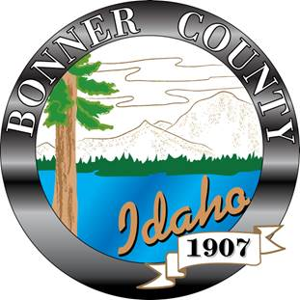 | BONNER COUNTY  HUMAN RESOURCES  1500 Highway 2, Suite 337, Sandpoint, Idaho 83864  Telephone: (208) 265-1456  Fax: (208) 265-1457

TO: All Employees

FROM: Human Resources Department

DATE: September 8, 2021

SUBJECT: JOB ANNOUNCEMENT POSITION

Position: Staff Attorney/Law Clerk
Department: Courts
Starting Pay: $58,000 (annual) DOE
Closing Date: Until Filled

Position Summary: The District Court Staff Attorney/Law Clerk performs highly responsible law clerk work for the District Judge, Magistrate Judges, and other court personnel relating to the administration of the district court, under the supervision and direction of the District Judge. In the role of an attorney, the staff attorney /Law Clerk advises the judge on administrative and ethical issues.

Other Information: The Staff Attorney/Law Clerk assists the Court through review of court files, pleadings, and briefs and through legal research to resolve legal issues in all civil and criminal matters. Work is generally regular and recurring. Judgment is required to apply practices and decision making within established, well-known procedures. Work is performed independently and with consultation with the judge. Research, document drafting, and other related duties are performed independently and with consultation with the judge. The Staff Attorney/Law Clerk works at a high level of responsibility as he/she works with court issues that will have a significant impact on the effectiveness of the judge and the operations of the District Court. Intermittent supervision is received. Work is performed in an office environment with high intermittent stress due to deadlines. The Staff Attorney/Law Clerk sometimes must perform work on an emergency basis. Workload may require evening, early morning, and/or weekend hours in addition to a 40-hour workweek. Job does not typically involve travel.

Specifications:
- Graduate from an accredited law school. Juris doctorate degree required with high academic standing.
- Admission to practice law in the State of Idaho preferred but not required.
- This position requires significant legal research and writing experience. Law Review experience preferred. Legal intern or prior law clerk experience preferred. High academic marks in legal research and writing course preferred. .
- Knowledge of local, state and federal law.

To Apply: Please visit our website at https://www.bonnercountyid.gov/departments/HR/current-openings. Click on APPLY HERE, this will take you to our Munis Self Service system. Follow the instructions to register and apply on line for the position.

Veteran’s Status: Bonner County will grant a preference to employment of veterans of the U.S. Armed Services in accordance with provisions of Idaho Code § 65-503 or its successor. In the event of equal qualifications for an available position, a veteran or family member who qualifies for preference pursuant to Idaho Code § 65-503 or its successor will be employed.

