CHIEF JUDGE/ELECTION SUPERVISOR MANUAL

IDAHO ELECTIONS

WELCOME 3
ELECTIONS POLICIES AND EXPECTATIONS 4 Pre-Election Day Expectations 4
Election Day Expectations 6
LEGAL RESPONSIBILITIES 11
Electioneering 11
Firearms 11
Accessibility 12
OPENING THE POLLING PLACE 15
Poll Worker Opening Procedures 18
First Voter Procedures 20
ELECTION DAY GUIDES 23
Voting Line Clerk Reference Guide 24
Poll Book Clerk Reference Guide 25
Voter Registration Clerk Reference Guide 30
Ballot Issuing Clerk Reference Guide 33
Ballot Receiving Clerk Reference Guide 35
Polling Place Public Health Procedures 38
CLOSING THE POLLING PLACE 40
Poll Worker Closing Procedures 42
FREQUENTLY ASKED QUESTIONS 44
ANNUAL ELECTIONS CALENDAR 45
APPENDIX A - POLLING PLACE ASSEMBLY DIAGRAM 46
APPENDIX B - VOTER PROOF OF IDENTITY REQUIREMENTS 47
APPENDIX C - SAMPLE FORMS 49
APPENDIX D - SAMPLE FAQ 52
APPENDIX E - IDAHO STATE CODE 58

WELCOME!

Thank you for your willingness to serve as a Chief Judge. Your service is invaluable. Idaho could not pull off successful elections without people like you.
The guidelines provided in this manual are intended to help you successfully supervise a polling location on Election Day. Please take time to read this manual carefully prior to Election Day and use it as a reference at the polls.

We hope that supervising a polling location proves to be a rewarding experience. Thank you for your service and for taking an active role in your democracy.

ELECTIONS POLICIES AND EXPECTATIONS

Pre-Election Day Expectations

Chief Judge

The Chief Judge (this position is sometimes called “Election Supervisor,” but will be referred to as “Chief Judge” throughout this manual) is the main point person in charge of running a polling location in accordance with federal and state law and the county’s instructions. This role is critical to a successful Election Day. The following information relates to the Chief Judge selection process and responsibilities.

Selection

County Elections Offices select a Chief Judge to supervise each of their polling locations (which may include one or more precincts), typically one to two months before an election.

Training

Chief Judges are required to attend a training prior to each election. The purpose of the training is to prepare Chief Judges for Election Day. Training classes provide a general overview of election procedure and any updates to applicable laws or policies. Training classes typically run two to three hours. If you are unsure how to sign up for a training class, contact your County Elections Office.

Go Vote!

Since you will be busy on Election Day, it is critical to make sure your voice is heard by taking advantage of options to vote early or by absentee ballot. You may go to your County Elections Office website to get election-specific updates on where and when you can cast your ballot.

Selecting Poll Workers

Each polling location you run is allotted a certain number of poll workers for each election. Every election is different so the poll worker allotment for a given polling location can change from election to election.

Your County Elections Office may allow you to choose your poll workers for your polling location. If they do, submit your poll workers’ names and contact information to your County Elections Office. Alternatively, your County Elections Office may assign poll workers to your polling location as needed. You are responsible for ensuring that your polling location is fully staffed before Election Day and should contact your County Elections Office if you need additional poll workers.

All poll workers must be at least 16-years-old.

It is recommended that poll workers have some prior exposure to the voting process. This is not, however, a requirement for serving as a poll worker.

Each polling location is limited to two student poll workers (a student poll worker is one who is not yet eligible to vote but is at least 16-years-old and a citizen of the United States).

All poll workers are paid for their time on Election Day at an amount set by the county, but not less than the state’s minimum wage, as stated in Title 34, Chapter 3, Section 3 of Idaho State Code (§ 34-303).

Poll workers should follow the instructions from their county carefully to ensure they receive payment for their time (and reimbursement for mileage when applicable).

Election Equipment

Your election equipment—such as electronic poll books (ePollbooks), paper poll books, ballots, ballot scanners, and ballot boxes—must be subjected to strict chain-of-custody and security protocols. Therefore, this equipment will either be dropped off at your polling place by County Elections Office staff or you will be given a specific date and time to pick it up.

If you are asked to pick up your election equipment, be aware that the equipment could be bulky and take up quite a bit of space in your vehicle. Please ensure you have sufficient space in your vehicle to accommodate all of the necessary equipment.

Polling Place

It is critical that you contact your polling place ahead of Election Day. Some polling places require a key code or door key for access ahead of Election Day, so it is important to communicate with your polling place’s onsite contact(s). If your polling location is at a school or church, the contact is typically the administration office or pastor. Let them know that you are the Chief Judge working at the polling place. Please direct any polling place-related questions to your County Elections Office.

Set up on the Monday before Election Day. Consider setting up the Monday evening before Election Day to reduce the amount of time it takes to set up on the morning of the election. This will help ensure that your polling place is ready to go well before polls are required to open at 8:00AM. Be sure to work out a plan with the polling place contact before you arrive the day before to set up, and keep in mind that election equipment is not typically delivered until the late afternoon on the Monday prior to Election Day (in some instances, election equipment may be delivered early on election morning). Be sure not to leave any equipment that must remain in your custody at your polling location overnight.

Discipline/Dismissal

Chief Judges and poll workers are election officials directly responsible for upholding the democratic process and representing their county.

All staff at the polls are expected to adhere to the policies and procedures outlined in this manual, as well as the laws of the state of Idaho and federal law. Poll workers may be warned or dismissed for failing to adhere to relevant policies, procedures, and statutes.

Election Day Expectations

Reminders

- Check in with your poll workers prior to Election Day. Typically, Chief Judges check in with poll workers the weekend before Election Day. If a poll worker tells you they will be unable to staff the polling location, you should notify your County Elections Office right away.
- Bring your notes and this Chief Judge manual with you on Election Day.
- Maintain a consistent presence. It is important for Chief Judges to be available throughout the day in case questions arise. For this reason, you must stay at your polling place the entire day. If you need to step away from the voting area briefly (e.g. to take a personal phone call), please make sure your Assistant Chief Judge is available for questions. If you do not have an Assistant Chief Judge, please make sure your poll workers know where to find you or have the correct County Elections Office contact number(s) for election-related questions.

- If you are ill on Election Day, please stay home. Call your County Elections Office as soon as possible so they can fill your position.

- Plan ahead for meals/snacks. You are welcome to order food for delivery to your polling place. Otherwise, please bring all necessary food, drinks, and medication with you on Election Day so that you can remain at your polling place the entire day. Typically, Chief Judges work out a food plan with their poll workers ahead of Election Day.
- Limit use of personal electronic devices. Please do not use smartphones, laptops, or tablets while seated at your polling station for personal business if voters are present in the polling place. If a poll worker needs to use their phone while voters are present, for purposes other than communicating with their County Elections Office, please ask that they leave their station and step away from the voting area to use it.

Same-Day Voter Registration

In Idaho, voters are allowed to register to vote on Election Day, per Title 34, Chapter 4, Section 8A of Idaho State Code (§ 34-408A). You can find the personal identification requirements for same-day voter registration in Appendix B of this manual and in this manual’s Voter Registration Clerk Reference Guide.

Voter Check In (for pre-registered voters)

The identification requirements for voters who are already registered to vote are different from those for same-day voter registration.

Voters who are already registered to vote are required to show photo identification before they vote at their polling place, as required by Title 34, Chapter 11, Section 13 of Idaho State Code (§ 34-1113). The types of personal identification that may be used to check in pre-registered voters on Election Day are outlined in Appendix B of this manual and in this manual’s Poll Book Clerk Reference Guide.

After the voter shows the required proof of identity, the Poll Book Clerk must have the voter state their full name and address, as required by Title 34, Chapter 11, Section 6 of Idaho State Code (§ 34-1106).

Personal Identification Affidavit

If a voter is unable to provide one of the five required types of identification when checking in, the voter may instead fill out a Personal Identification Affidavit.

[Note: The Personal Identification Affidavit cannot be used to verify identity for purposes of same-day voter registration.]

Absentee Ballots

In Idaho, voters can request an absentee ballot for any election throughout the year, for any reason. If a voter has received but not cast an absentee ballot, they are permitted to vote in person on Election Day.

If a voter brings in their absentee ballot to your polling place with the expectation of submitting their voted absentee ballot at your polling place, please inform them that they may not do so. Polling places are typically not allowed to accept voted absentee ballots; absentee ballots should instead typically be dropped off at the County Elections Office between 8:00AM and 8:00PM on Election Day. If, however, your county has provided your polling location with specific instructions for accepting absentee ballots on Election Day, follow those procedures.

If a voter would like to cast a vote in person instead of voting their absentee ballot, they may.

If the voter has brought their absentee ballot with them, you must spoil their absentee ballot by writing “SPOILED” on the outer envelope or, if the ballot is not in an envelope, by writing “SPOILED” on the ballot itself (poll workers may not open an absentee ballot envelope under any circumstances). You must keep the spoiled ballot for return to your County Elections Office on election night (you should have a designated envelope or bag for storing your spoiled ballots). After you have spoiled the voter’s absentee ballot, you may then vote the voter at your polling place, following the protocols outlined in this manual.

If the voter has not brought their absentee ballot with them, take the following steps: If your county uses ePollbooks, the voter’s absentee ballot will be spoiled automatically by the ePollbooks system when you check them in to vote at your polling place. If your county uses a paper poll book, call your County Elections Office immediately, confirm that the voter’s absentee ballot has not already been counted, and, if it has not, notify the County Elections Office that the voter is voting in person and the County Elections Office should spoil the voter’s absentee ballot.

Poll Worker Role Review

There are several unique roles that poll workers might fulfill at the polling place. Check with your County Elections Office to determine if they or you, as Chief Judge, are responsible for assigning poll workers specific clerk roles. As the Chief Judge, you are responsible for supervising all poll workers throughout the day. You should not regularly work one of the clerk roles; you should only provide relief to your poll workers for short periods of time, so that you are free to supervise, answer questions, and troubleshoot issues.

- Chief Judge/Election Supervisor
  - Manages the polling place and its poll workers.
  - Observes and enforces election procedures as defined by the County Elections Office, including but not limited to:
    - Voter registration and identification laws;
    - Electioneering; and
    - Accessibility.
  - Answers voter and poll worker questions and solves problems.
  - Facilitates the delivery, pick up, and drop-off of critical voting equipment before Election Day and after polls close.

- Voting Line Clerk/Greeter/Vote Area Monitor/Rover (referred to as “Voting Line Clerk” throughout this manual. Not all polling locations will have this position.)
  - Sets up sanitizing stations.
  - Greets voters as they enter the polling place and directs them to the appropriate poll worker with questions and prompts such as:
    - “Are you registered?”
      - Provides voters with Voter Registration Cards when needed.
    - “Have your identification ready!”
  - Alerts Chief Judge to any observed issues related to electioneering or polling place accessibility.

- Poll Book Clerk/Check In Clerk (referred to as “Poll Book Clerk” throughout this manual)
  - Works the poll book station, checking in voters.
  - Checks voters’ photo identifications.
  - Helps direct voters to their correct polling place, if needed.
  - Ensures Voter Registration Cards are completed accurately.
  - Issues voter tickets, if applicable, once voters are checked in.
  - Retains spoiled ballots and spoiled absentee ballots.
  - Uses the poll book for all required accounting, if applicable.

- Voter Registration Clerk/Registrar (referred to as “Voter Registration Clerk'' throughout this manual. This position might be combined with the Poll Book Clerk position in counties using ePollbooks, so that the responsibilities of both the Poll Book Clerk and Voter Registration Clerk are performed by the Poll Book Clerk.)
  - Checks voters’ photo identifications.
  - Ensures voters accurately and completely fill out their Voter Registration Cards.
  - Inputs the information provided by voters on their Voter Registration Cards into the ePollbook or paper poll book.

- Ballot Issuing Clerk
  - Ensures voters receive the ballot that corresponds with their precinct and voter ticket, if applicable.
  - Gives voters voting instructions.

- Ballot Receiving Clerk/Exit Clerk (referred to as “Ballot Receiving Clerk” throughout this manual)
  - Directs the voter to deposit their ballot directly in the ballot box or ballot scanner.
  - In polling locations with ballot scanners, assists voters with ballot-scanning issues, including walking voters through overvotes or directing voters who want to spoil their ballot to the Poll Book Clerk.
  - Audibly announces the voter’s name after they deposit their ballot directly in the ballot box or ballot scanner.
  - Offers “I Voted” stickers to voters once they have deposited their ballots and their name has been announced.
  - Directs voters to the exit.

- Constable (not all polling locations will have this position. This manual does not further address constable duties.)
  - Performs the duties outlined in Title 34, Chapter 11, Section 5 of Idaho State Code (§ 34-1105)

Assistance for Chief Judges

If there is an issue on Election Day or a question that comes up, contact your County Elections Office for assistance.

Your County Elections Office’s contact information will be available in the weeks leading up to the election. It is recommended that you save your County Elections Office’s phone number in your cell phone so that you can easily contact the Office throughout Election Day.

LEGAL RESPONSIBILITIES

Electioneering

Poll workers are not permitted to discuss politically-related news or topics while the polls are open on Election Day. If the conversation topic has anything remotely to do with politics, it is not appropriate. Reports of poll workers discussing politically-related topics can be grounds for immediate dismissal.

Title 18, Chapter 23, Section 18 of Idaho State Code (§ 18-2318) states that electioneering is prohibited at the polling place (including within 100 feet of the polling place entrance). Idaho Code does not define “electioneering.” Electioneering is generally understood, however, to refer to activities promoting a particular candidate, cause, or issue on the ballot, or otherwise attempting to influence a person’s vote.

In October 2020, the Idaho Attorney General’s Office issued an opinion to the Kootenai County Elections Office which stated that Kootenai County should not prohibit political apparel at polling places under Title 18, Chapter 23, Section 18 of Idaho State Code (§ 18-2318) (Idaho’s electioneering statute). Your County Elections Office has carefully reviewed Title 18, Chapter 23, Section 18 of Idaho State Code (§ 18-2318) as well as the Idaho Attorney General’s 2020 opinion on electioneering and will provide you with instructions on how to handle political apparel on Election Day.

At the beginning of Election Day, before polls have opened at 8:00AM, you must ensure that a “Vote Here” sign is posted 100 feet away from the polling place entrance. This sign will mark the closest that individuals gathering signatures or displaying or distributing campaign materials may be to the polling place entrance.

Firearms

Voters are permitted to carry firearms in the polling place, unless the polling place is a K-12 school. If a voter brings a firearm into a school, you are permitted to ask the voter to take the firearm back to their vehicle. However, if the voter refuses, you and your poll workers must allow them to vote.

If a voter enters your polling place with a firearm and you or your poll workers feel threatened, call 911 immediately.

Accessibility

Your County Elections Office ensures that all of its polling places are compliant with the Americans with Disabilities Act (“ADA”), or can be made ADA compliant. Some polling locations will require that poll workers implement temporary measures, like creating an ADA parking space or offering curbside voting, in order to ensure accessibility.

As a Chief Judge, you are directly responsible for maintaining ADA accessibility throughout Election Day at your polling location.

If your polling place requires temporary measures to be ADA accessible, you are responsible for verifying and documenting that the required measures were implemented (your County Elections Office may have a particular form for documenting this; if they do not, simply write down that the required measures were implemented and return this information to your County Elections Office with other Election Day materials).

Assisting Voters with Disabilities

General Guidelines

Individuals with disabilities prefer that you focus on their abilities, not their disabilities. They are due the same respect and consideration that you would show to any other voter. Please comply with the following:

- Use your normal voice when talking to people with disabilities.
- Talk directly to the individual in a clear and respectful manner.
- Never refer to anyone as handicapped or disabled as these are outdated terms. Person-first language, such as “voter with a disability” is preferred.
- Offer your assistance, but don’t assume a particular accommodation is needed. A voter may not want or need an accommodation. Let the voter explain what assistance would be helpful.
- Offer chairs when appropriate.
- Keep your polling place free of physical impediments that may interfere with a voter’s ability to maneuver.
- Be sensitive about physical contact. Startling someone may affect their ability to balance themselves.
- You may offer a voter the option to cast their ballot on the Touch Writer or other accessible voting machine, but the voter has the right to choose a paper ballot instead and may request assistance with reading and marking their paper ballot.
- Any poll worker can help a voter complete their ballot, as long as the voter first requests a poll worker’s assistance.
  - Poll workers may not, under any circumstances, influence a voter to vote in any particular manner. Poll workers may only read the ballot verbatim and record the voter’s intended selection.
    - If a voter is confused about who or what they are voting on, explain that poll workers can only read the ballot verbatim and record the voter’s selections. If a voter needs more time to figure out how to vote and wants to leave the polling place, their ballot can be spoiled and re-issued by your polling location any time before 8:00PM on Election Day.
    - Voters are permitted to refer to any materials they brought with them (including their cell phones) while voting.

Voters with Visual Impairments

- Always speak directly to the voter and identify who you are.
- Be descriptive with your language if you are helping a voter navigate the polling place.
  - Offer a voter your arm, but do not touch the individual unless you have their permission.
- If a voter has a guide dog, please do not pet or distract the dog—it is a working animal.

Voters with Mobility Impairments

- When you address a voter using a wheelchair or scooter, talk to them at their eye level.
- Never touch or lean on a voter’s mobility device unless you have their permission.
- Give a voter’s mobility device a push only when asked; don’t assume that they need you to assist their movement.
- Keep a voter’s crutches, canes, and walkers conveniently within their reach, if asked to hold them.
- If tables used for registration are not at a convenient height for voters in a wheelchair, offer a clipboard or another table/surface for writing.

Voters with Hearing Impairments

- Face voters when speaking to them so that they can see your lips.
- If requested, slow your speech, speak clearly, and increase your volume. Shouting is counterproductive.
- Communicate in writing or with gestures, if necessary.
- A voter may prefer to communicate using an ASL interpreter they have brought with them or via a telecommunications relay service, one of which is available by dialing 711. When communicating via an interpreter, talk directly to the voter, not the interpreter, but pause after each sentence to give the interpreter time to interpret.

Voters with Speech Impairments

- If you are unsure what a voter said, ask them to repeat themselves. Don’t become agitated if you have to make numerous attempts to understand a voter or to be understood.
- Do not complete a voter’s sentences. Allow voters to express themselves freely.

Voters with Service Animals

- Under the ADA, people with disabilities who use service animals have the right to bring their service animals into public places, which includes polling places. The ADA defines a service animal as a dog that is individually trained to perform a task related to the person’s disability.

- People using service dogs are not required to provide a certificate, license, or any other type of identification for the service animal. Staff may ask two questions: 1) Is this a service dog? 2) What tasks does it perform?

If you are unsure whether a dog is an ADA service animal, and the dog is not disruptive, simply allow the voter to vote. If the animal is disruptive, please ask its owner to address the issue. If this does not solve the problem, call your County Elections Office to discuss next steps.

OPENING THE POLLING PLACE

The following checklist is meant to help provide an order of operations for setting up your polling place on Election Day morning. As noted earlier, please try to set up your polling place on the Monday before Election Day by coordinating with your polling place contact. Setting up early helps Election Day morning move faster and guarantees that your polling place will be ready to open at 8:00AM.

Checklist

- Arrive at the polling place at 7:00AM
- Confirm all your poll workers have arrived
  - If you have no-shows, call your County Elections Office
- Locate election materials that have been dropped off and unpack those supplies
- Begin setting up your polling place
  - Every poll worker has their own role on Election Day and should set up and familiarize themselves with their respective stations
  - Ensure your polling place has a flow that will be easy for voters to understand and follow
    - Refer to Appendix A for an example of an effective polling place set up and flow
- Set up ballot box(es) and ballot scanner(s), if applicable
  - See spiral bound equipment guide for ballot scanner instructions and troubleshooting
  - You will need a code for the ballot scanner, which will be provided to you as the Chief Judge. If you cannot locate this code, contact your County Elections Office
- Set up the Touch Writer, AutoMARK, or other accessible voting machines provided
  - See the provided guide or checklist for instructions and troubleshooting for the accessible voting machine(s) in your polling location
  - Ensure the Touch Writer, AutoMARK, or other accessible voting machine is set up in an accessible area with privacy
- Set up outside signage
  - Place “Vote Here” signs 100 feet from polling place entrance
- Set up indoor signage
- Ensure all poll workers have clocked in on one ePollbook, if applicable, or have recorded their start times on their timesheets.
  - All poll workers should clock in on the same ePollbook
- Administer the Oath of Elections to all poll workers
- Make sure each poll worker has a reference sheet or other instructions for their clerk position available at their station throughout the day
- Complete the pre-opening checklist and walkthrough (if provided by your county)
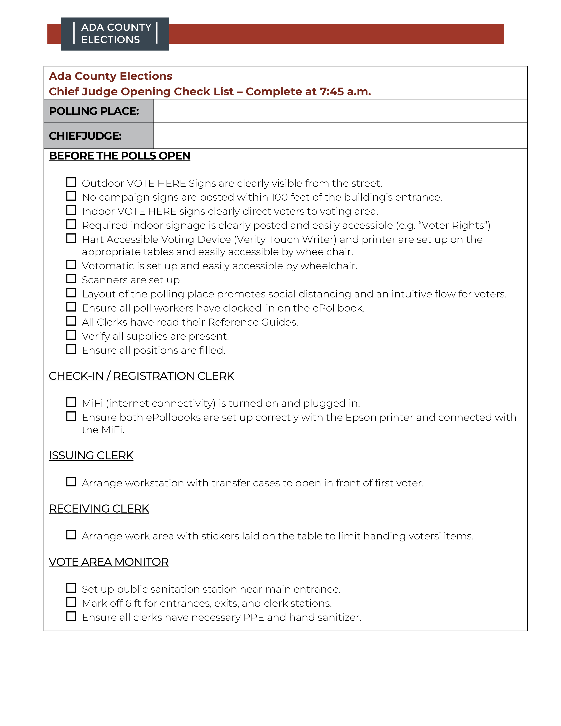
The following is a checklist that is used by Chief Judges in Ada County and can be referenced and/or adapted, if helpful.

Poll Worker Opening Procedures

Voting Line Clerk

- Assist your Chief Judge with setting up the tables and voting booths
(including the accessible voting booth(s)).
- Set up your work station near the main entrance of the polling place.
- Set up sanitizing stations.
- Set up the “Vote Here” yard signs.
- Assist other poll workers with their setup.
- Take the Oath of Elections and check in to an ePollbook or record your start time on your timesheet if your polling location is not using ePollbooks.
- Once setup is complete and the polls are about to open, ensure all poll workers have hand sanitizer and check the polling place entrance; notify your Chief Judge if you identify any barriers to voting such as accessibility or electioneering issues.

Poll Book and Voter Registration Clerks

- Assist your Chief Judge with setting up the tables and voting booths (including the accessible voting booth(s)).
- Make sure you have all items needed for your work station (if you have an inventory or checklist, review it). For precincts using ePollbooks, make sure you have all needed items in the ePollbook case.
- Arrange your work area so it is efficient for you and user-friendly for voters.
- Help set up indoor signage.
- Take the Oath of Elections and check in to an ePollbook or record your start time on your timesheet if your polling location is not using ePollbooks.
- If using an ePollbook, review the check-in procedures in the spiral bound ePollbook training guide.
- Assist your Chief Judge and other poll workers with final preparations.

Ballot Issuing Clerk

- Assist your Chief Judge with setting up the tables and voting booths (including the accessible voting booth(s)).
- Make sure you have all items needed for your work station (if you have an inventory or checklist, review it).
- Arrange your work area so it is efficient for you and user-friendly for voters.
- Help set up indoor signage.
- Take the Oath of Elections and check in to an ePollbook or record your start time on your timesheet if your polling location is not using ePollbooks.
- Assist your Chief Judge and other poll workers with final preparations.

Ballot Receiving Clerk

- Assist your Chief Judge with setting up the tables and voting booths
(including the accessible voting booth(s)).
- Set up the ballot box(es) and ballot scanner(s), if applicable.
- Make sure you have all items needed for your work station (if you have an inventory or checklist, review it).
- Arrange your work area so it is efficient for you and user-friendly for voters.
- Help set up indoor signage.
- Take the Oath of Elections and check in to an ePollbook or record your start time on your timesheet if your polling location is not using ePollbooks.
- Assist your Chief Judge and other poll workers with final preparations.

First Voter Procedures

Once the first voter arrives, there are specific steps to take as a Chief Judge:

- At or after 8:00AM, the first voter may enter the polling place.
- The voter must be checked in by the Poll Book Clerk.
- The Ballot Issuing Clerk will then open ALL of the transfer cases containing the unused ballots in front of the first voter to show the first voter that the ballots have been kept secured prior to the start of voting
  - As the Chief Judge, you will then need to fill out the Ballot Receiving Log or your county’s chosen recording form to verify that all the unused ballots assigned to your precinct(s) have arrived.

Ballot Receiving Log Example
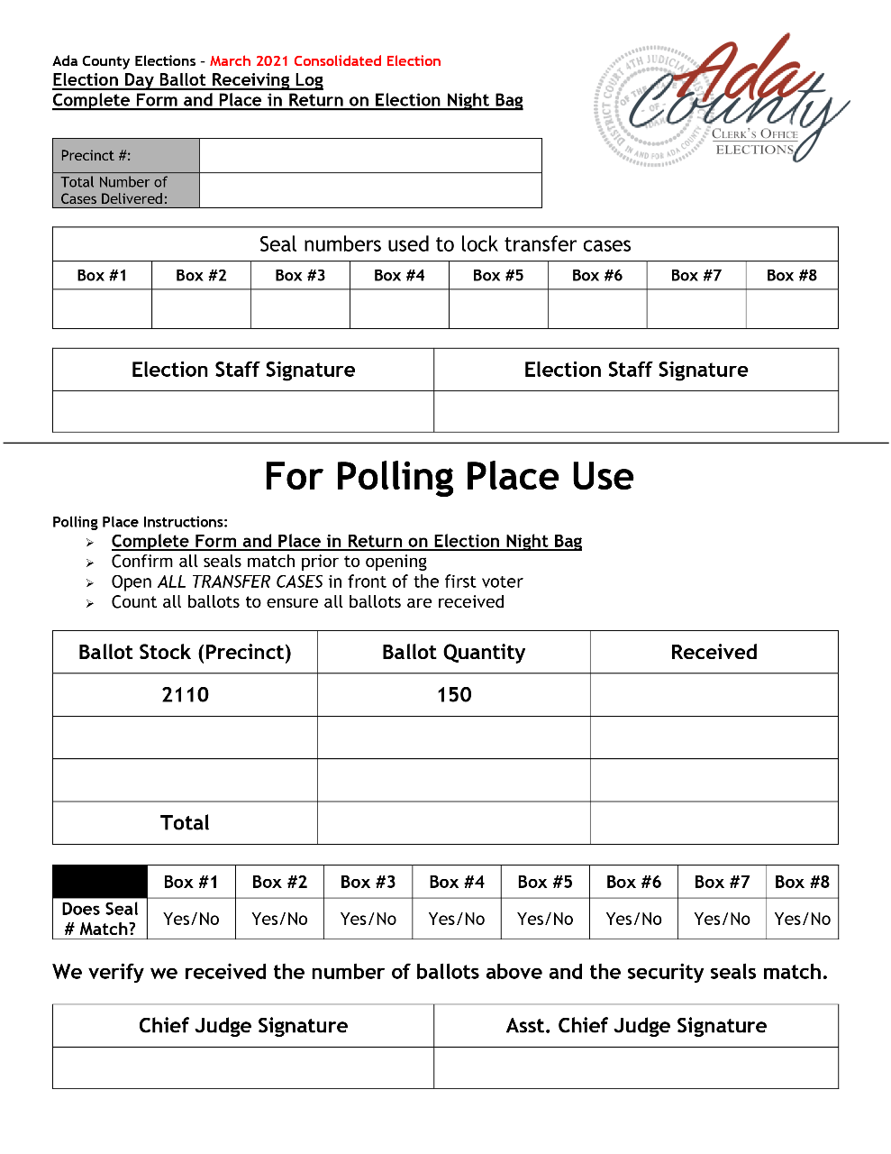

- The first voter will then be issued their ballot; they may now mark it.
- Once the first voter has finished marking their ballot, ensure the ballot boxes are open so the first voter can verify that they are empty.
- Once the first voter verbally verifies that the boxes are empty, you may lock the ballot boxes and attach the plastic security seals.
- The first voter must then fill out a Ballot Box Witness Affidavit, prior to depositing their ballot directly in a ballot box or in the ballot scanner, if applicable.

Ballot Box Witness Affidavit Example

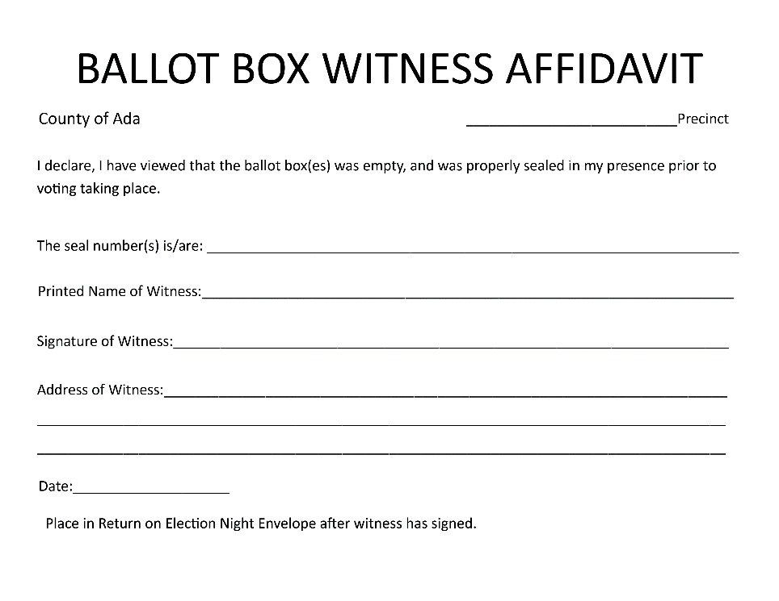

- The Ballot Receiving Clerk then asks and announces the voter’s name.
- Finally, the Ballot Receiving Clerk offers the voter an “I Voted” sticker.

Sample Polling Place Layout

Try to follow this layout to the best of your ability at your polling location. Please note that there are two ADA booths set up in the example below, designating the location of accessible voting machines such as a Touch Writer or Votomatic. These booths ensure that polling places are ADA compliant and that all voters have equal opportunity to cast their ballot, regardless of their abilities.

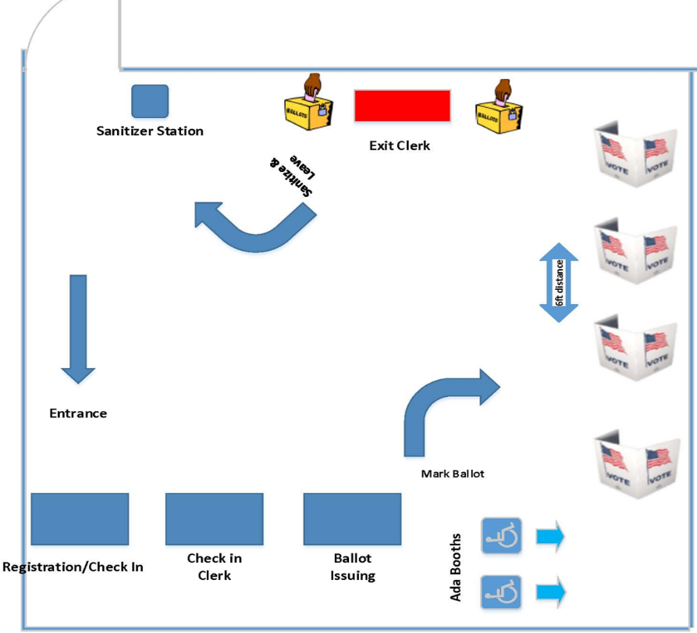

ELECTION DAY GUIDES

The following guides are provided to clarify the expectations for each poll worker position. Please make sure each poll worker has their corresponding guide for reference throughout the day.

In order:

- Voting Line Clerk
- Poll Book Clerk
- Voter Registration Clerk
- Ballot Issuing Clerk
- Ballot Receiving Clerk
- Polling Place Public Health Procedures

Voting Line Clerk Reference Guide

Clerk Position Overview: The Voting Line Clerk is responsible for greeting voters as they walk in the polling place and for keeping lines moving efficiently.

Greeting and directing voters helps reduce voter confusion and helps speed up the voting process. By asking voters if they’re already registered to vote or if they have changed their name or residence address, Voting Line Clerks can quickly identify those voters who need to fill out a Voter Registration Card (and provide voters with a Voter Registration Card, clipboard, and pen while in line) and direct voters to the appropriate poll worker.

Before the Polls Open

- If applicable, set up the public sanitation station near the main entrance of the polling place.
- Set up the “Vote Here” signs outside.
- Assist other poll workers with their setup.
- Take the Oath of Elections and clock-in to the ePollbook, if applicable, or record your start time on your timesheet.
  - Everyone should clock in on the same ePollbook.
- Once setup is complete and polls are about to open, ensure that all poll workers have hand sanitizer (if provided).

After the Polls Open

- Greet voters as they walk through the door and ask them if they are registered or need to change their name or address; direct voters accordingly.
- Answer any questions voters may have about the process.
- Pass out Voter Registration Cards and clipboards to voters in line who need to register to vote or change their name or address on their voter registration.
- Alert your Chief Judge if you see any persons who appear to be electioneering.
- Alert your Chief Judge if you identify other potential barriers to voting at your polling location.
- Occasionally check empty voting booths and remove any items left behind or cover up any writing on the voting booth.

After the Polls Close

- Pick up the signs outside and take down signs inside the polling place.
- Clean up the polling place and pack up all supplies.
- Assist other poll workers with closing the polls as needed.

Poll Book Clerk Reference Guide

Clerk Position Overview: The Poll Book Clerk is responsible for checking in registered voters and, in many polling locations, also for registering new voters. In some polling locations, the Poll Book Clerk’s responsibilities listed below will be split between two positions, a Check In Clerk and a Voter Registration Clerk.

This position has the most responsibility on Election Day, so it is important to know the relevant statutory requirements and procedures as listed below. Reviewing these requirements and procedures consistently throughout the day could be helpful, and will save you from having to memorize all the different acceptable forms of identification.

Before the Polls Open

- Assist your Chief Judge in setting up the tables and the voting booths.
- If applicable, make sure you have all items included with the ePollbook case.
- Arrange your work area according to the assembly diagram found in Appendix A to this manual.
- Help set up indoor signage.
- Take the Oath of Elections.
- Clock-in to an ePollbook (every poll worker should clock in on the same ePollbook) or enter your start time on your timesheet if your polling location is using a paper poll book.
- Review your county’s check-in procedures or ePollbook training guide.
- Assist your Chief Judge and/or fellow poll workers with final preparations.

After the Polls Open

Step-by-step guide to checking in voters using an electronic poll book (ePollbook)

- Locate the voter in the ePollbook or paper poll book.
  - Process the voter as a “check-in” in the ePollbook.
- Ask the voter to state their name and address and confirm their statement matches the information displayed on the ePollbook screen or in the paper poll book. Do not prompt the voter by reading the address displayed on the ePollbook screen or in the paper poll book next to their name.
  - If using an ePollbook, check to make sure the voter is in the correct precinct.
  - If using a paper poll book that does not contain the voter, use the method provided by your County Elections Office to confirm that the voter is in the correct precinct.
  - If the voter is not in the correct precinct, direct the voter to their precinct.
  - If the voter is in the correct precinct, but not registered to vote in the precinct, direct the voter to the Voter Registration Clerk or register the voter, if that is one of your assigned duties.
    - If the voter is in the right precinct and believes that they are already registered to vote in the precinct, contact your County Elections Office.
- Review the voter’s photo identification (make sure they provide one of the accepted types—see below or Appendix B) or instruct the voter to sign a Personal Identification Affidavit if they do not have one of the accepted types of identification.
  - Note: If the address on the voter’s identification does not match that printed in the poll book, that is acceptable, as long as the voter has stated the address printed in the poll book.
- Direct the voter where to sign on the ePollbook.
  - Title 34, Chapter 11, Section 6 of Idaho State Code (§ 34-1106) requires that the voter desiring to vote, and no one else, sign the poll book. Encourage voters to sign or make a mark in whatever way they can.
- Issue the voter a secrecy envelope and voter ticket, if applicable.
- Direct the voter to the Ballot Issuing Clerk to receive their ballot.

Step-by-step guide to checking-in voters using a paper poll book

- Ask for the voter’s name.
- Find the voter’s name in your poll book.
- Ask the voter to state their address and confirm their statement matches the address listed in your poll book from the voter roll.
  - Do not prompt the voter by reading the address printed in the poll book next to their name.
- If you cannot find the voter in the poll book, confirm that the voter is in the correct precinct using the procedure provided by your County Elections Office.
  - If the voter is in the correct precinct, direct the voter to the Voter Registration Clerk or register the voter to vote, if that is one of your assigned duties.
  - If the voter is not in the correct precinct, direct the voter to their precinct.
- Review the voter’s photo identification (make sure they provide one of the accepted types—see below or Appendix B) or instruct the voter to sign a Personal Identification Affidavit if they do not have one of the accepted types of identification.
  - Note: If the address on the voter’s identification does not match that printed in the poll book, that is acceptable, as long as the voter has stated the address printed in the poll book.
- Direct the voter to sign the poll book.
  - Title 34, Chapter 11, Section 6 of Idaho State Code (§ 34-1106) requires that the voter desiring to vote, and no one else, sign the poll book. Encourage voters to sign or make a mark in whatever way they can.
- Mark in your poll book that the voter has been checked in to vote.
- Issue the voter a secrecy envelope and a voter ticket, if applicable.
- Direct the voter to the Ballot Issuing Clerk to receive their ballot.

After the Polls Close

Step-by-step guide using an electronic poll book (ePollbook)

- Make sure all poll workers clock out for the day (everyone should clock out on the same ePollbook).
- Select “Logout” on the ePollbook screen and then select “Close the Polls.”
- Complete all “Accounting” on the ePollbook screen for the day.
  - Refer to the ePollbook guide for more information.
- Return all equipment to the ePollbook case as shown in the loading diagram found in the ePollbook case.
- Assist the Chief Judge in taking down the polling place.

Step-by-step guide if using a paper poll book

- Fill out the “accounting section” at the front of the poll book.
- Assist your Chief Judge in taking down the polling place.

Voter Check In Proof of Identity Requirements

Title 34, Chapter 11, Section 13 of Idaho State Code (§ 34-1113) states that all voters must show one of the following forms of identification prior to signing the poll book and voting:

- An Idaho Driver's License or identification card issued by the Idaho Transportation Department;
- A passport or an identification card that includes a photograph issued by an agency of the U.S. government;
- An identification card that includes a photograph issued by a tribal government located within the United States;
- A current student identification card that includes a photograph issued by a high school or an accredited institution of higher education that is located within the state of Idaho, including a university, college, or technical school; or
- A license to carry concealed weapons issued under Title 18, Chapter 33, Section 2 of Idaho State Code (§ 18-3302), or an enhanced license to carry concealed weapons issued under Title 18, Chapter 33, Section 2K of Idaho State Code (§ 18-3302K).

What if a Voter Doesn’t Have Proof of Identity?

Title 34, Chapter 11 Section 14 of Idaho State Code (§ 34-1114) states that a voter may check in at a polling place by completing a Personal Identification Affidavit in lieu of showing one of the above listed forms of personal identification. This option is not available to voters registering to vote on Election Day; this option only applies after a voter is registered.

Spoiling Ballots

Ballots Issued on Election Day

If a voter makes a mistake while marking their ballot and would like
another ballot, write “SPOILED” in large letters across the ballot
containing the mistake. Keep all spoiled ballots in one place and return them
to your County Elections Office on election night.

If using an ePollbook, select “Spoil/Cancel Check-In” from the dropdown
menu and go through the steps to check the voter back in and reissue them
a ballot. If needed, refer to the ePollbook guide for directions.

If spoiling a ballot using a paper poll book, indicate in the paper poll book that the voter’s ballot has been spoiled.

Absentee Ballots

Sometimes a voter who requested and received an absentee ballot
wants to vote at their polling place on Election Day. To vote the voter, you must take the following steps:

If the voter has brought their absentee ballot with them, you must spoil their absentee ballot by writing “SPOILED” on the outer envelope or, if the ballot is not in an envelope, by writing “SPOILED” on the ballot itself (poll workers may not open an absentee ballot envelope under any circumstances). You must keep the spoiled ballot for return to your County Elections Office on election night (you should have a designated envelope or bag for storing your spoiled ballots). After you have spoiled the voter’s absentee ballot, you may then vote the voter at your polling place, following the protocols outlined in this manual.

If the voter has not brought their absentee ballot with them, take the following steps: If your county uses ePollbooks, the voter’s absentee ballot will be spoiled automatically by the ePollbooks system when you check them in to vote at your polling place. If your county uses a paper poll book, call your County Elections Office immediately, confirm that the voter’s absentee ballot has not already been counted, and, if it has not, notify the County Elections Office that the voter is voting in person and the County Elections Office should spoil the voter’s absentee ballot.

Voter Registration Clerk Reference Guide

Voter Registration Overview: Processing same-day voter registrations is an integral part of the polling place operation on Election Day. It is imperative to follow the law as outlined in Title 34, Chapter 4, Section 8 of Idaho State Code (§ 34-408A).

A voter needs to re-register to vote if:

- They’ve never registered in their county;

- They’ve changed their name or address since they last registered to vote in their county; or

- Their county purged the voter from the voter rolls due to inactivity.

A How-to Guide:

- Prior to registering or re-registering a voter, make sure the voter is in the correct precinct, using the ePollbook or, if using a paper poll book, the procedure provided by your County Elections Office.

  - If the voter is in the wrong precinct, direct them to the correct precinct to register to vote and vote.

- Have the voter fill out a Voter Registration Card; review the Card to ensure it is complete and the voter is eligible to vote.

  - To process a Voter Registration Card, the voter must legibly provide the information highlighted on the sample Card shown below.
    - Only their date of birth must be filled out in row 4.
    - Rows 7 and 8 do not need to be filled out to register a voter. If row 7 is left blank, the voter is simply “unaffiliated.”

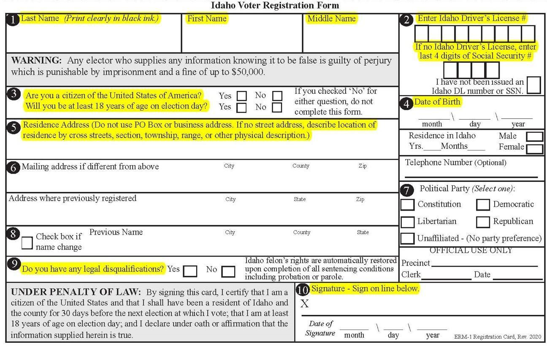

  - To process a Voter Registration Card, the voter must indicate the following on their Card:
    - Row 3—the voter is a U.S. citizen and at least 18-years-old.
    - Row 9—the voter has no legal disqualifications.

- Review the voter’s proof of identity (see below or Appendix B) and proof of residency (any document from a third party displaying the address of their residence).

- Verify that the voter’s proof of identity and residence match what has been written on their Voter Registration Card.

- Complete the required fields in the “OFFICIAL USE ONLY” box on the registration card as follows:

  - Precinct—fill in the precinct number that corresponds with the precinct that you are working (if working a dual precinct, fill in the precinct in which the voter is eligible to vote).
  - Poll worker—fill in your initials.
  - Date—fill in the Election Day date.

- Indicate on the Voter Registration Card that you have verified the voter’s information.
- If using an ePollbook, exactly copy the information on the voter’s Voter Registration Card into the ePollbook. If using a paper poll book, copy the voter’s name and address into the blank Same-Day Voter Registration poll book page.
  - Save all Voter Registration Cards in an envelope or bag for return to your County Elections Office on election night.

- After you have registered the voter, the voter can be checked in. For check-in instructions, review the “Poll Book Clerk Reference Guide.”

Voter Registration Proof of Identity Requirements

Title 34, Chapter 4, Section 8A of Idaho State Code (§ 34-408A) states that all voters registering to vote on Election Day must show one of the following forms of identification prior to signing the poll book and voting:

  - An Idaho Driver’s License or Idaho identification card issued by the Idaho Transportation Department;
  - A photo identification and a document showing a valid address in the precinct; or
  - A current, valid student photo identification card issued by a postsecondary institution in Idaho and a current student fee statement showing the student’s valid address in the precinct.

Registration Considerations

If a voter does not have a valid residential address or is unhoused or staying in temporary housing, they can register using a shelter address or the address of a cross street or park where they usually sleep, so long as they otherwise qualify to vote and can provide proof of residency at the address listed. Contact your County Elections Office for directions regarding what you can accept as proof of residency if this situation arises (e.g., a proof of residency letter from a shelter).

Voters are not permitted to register to vote using a P.O. Box under any circumstances. Voters are also not permitted to register to vote using a business address, unless they are currently living at the business address. If a voter attempts to register to vote at a P.O. Box or at a business address where they are not living, please ask them to list their actual residence address on their Voter Registration Card.

Ballot Issuing Clerk Reference Guide

Clerk Position Overview:

- Issues ballots
- Secures ballot stubs not in use
- Clarifies voting instructions for voters
- Directs voters to available voting booths

Before the Polls Open

- Assist your Chief Judge with setting up the tables and the voting booths.
- Make sure you have all required supplies.
- Arrange your workstation.
- Help set up indoor signage.
- Take the Oath of Elections and clock-in on an ePollbook (everyone should clock in on the same ePollbook) or enter your start time on your timesheet if your polling location is using a paper poll book.
- Assist your Chief Judge and other poll workers with final preparations.

After the Polls Open

The First Voter of the Day

- Make sure the first voter has been checked in and has a secrecy envelope and voter ticket, if applicable.
- Have the first voter observe the unlocking of ALL the transfer case(s).
- Wait for your Chief Judge to fill out the Ballot Receiving Log or the recording system used in your county to verify that all the unused ballots assigned to the polling location arrived.
- Arrange ballots in sequential and code order.
- Keep the lowest numbered ballots at your station. Place the rest of the ballots in a secure location where they can be observed by a poll worker at all times.

All Other Voters

- Make sure every voter who approaches your station has a secrecy envelope and voter ticket, if applicable.
- Once a voting booth is available, carefully tear off one ballot (may include multiple pages) from the ballot stub, put it in the secrecy envelope, and hand it to the voter. If your polling location serves more than one precinct, make sure the voter receives the correct ballot type for their precinct.
  - Sever ballots from the ballot stub in numerical order; each page of the ballot stub is numbered and coded.
    - Once you have issued the last ballot on a stub, save the stub.
    - If a ballot is severed from the stub and is not used, spoil it by writing, “DETACHED, NOT USED – SPOILED” and save it with the other spoiled ballots.
- Instruct the voter to mark their ballot at the voting booth and then deposit their ballot directly in the ballot box or ballot scanner, if applicable.
  - Remind voters not to fold their ballot.
  - A voter may request any assistance they would like while casting their ballot so long as the assistance does not disrupt the polling place, and nothing is left behind in the voting booth (occasionally check voting booths and remove or cover up any writing left in or on the voting booth).
    - Poll workers may not, under any circumstances, influence a voter to vote in any particular manner. Poll workers may only read the ballot verbatim and record the voter’s intended selection.
      - If a voter is confused about who or what they are voting on, explain that poll workers can only read the ballot verbatim and record the voter’s selections. If a voter needs more time to figure out how to vote and wants to leave the polling place, their ballot can be spoiled and re-issued by your polling location anytime before 8:00PM on Election Day.
      - Voters are permitted to refer to any materials they brought with them (including their cell phones) while voting.
- Direct the voter to an open voting booth.

After the Polls Close

- Count the total number of unused ballots; give the count to your Chief Judge.
- Count the total number of spoiled ballots (those issued and spoiled at the polls); give count to your Chief Judge.
- Give the following items to your Chief Judge:
  - UNUSED BALLOTS
  - SPOILED BALLOTS
  - SPOILED ABSENTEE BALLOTS
  - BALLOT STUBS
- Pack up your supplies.
- Assist your Chief Judge in counting ballots and taking down and packing up the polling place.

Ballot Receiving Clerk Reference Guide

- Clerk Position Overview: The Ballot Receiving Clerk keeps the ballot boxes secure, directs voters to deposit their ballot either directly in the ballot box or, if applicable, in a ballot scanner, announces voter names, offers voters “I Voted” stickers, and directs voters to the polling location exit.

Before the Polls Open:

- Assist your Chief Judge in setting up tables and voting booths.
- If applicable, set up the ballot scanner(s).
- Make sure you have all needed supplies.
- Arrange your work area.
- Help set up indoor signage.
- Take the Oath of Elections and clock-in on an ePollbook (everyone should clock in on the same ePollbook) or enter your start time on your timesheet if your polling location is using a paper poll book.
- Assist your Chief Judge and other poll workers with final preparations.

After the Polls Open:

The First Voter of the Day

- Open the ballot boxes so the first voter can verify that they are empty.
- Once the first voter verbally verifies that the ballot boxes are empty, wait for your Chief Judge to lock the ballot boxes and put on the plastic security seals.
- Have the voter fill out the BALLOT BOX WITNESS AFFIDAVIT form (see sample below).

- Have the voter deposit their ballot either directly in the ballot box or in a ballot scanner, if applicable.
- Ask the voter their name.
- Announce, “[voter’s name] has voted” in a clear and audible voice.
- Offer the voter an “I Voted” sticker.
- Direct the voter to the polling location’s exit.

All Other Voters

- Maintain the security of the ballot box(s) and, if applicable, ballot scanner(s).
- Collect secrecy sleeves from voters and either stack them for pick up by the Issuing Clerk or periodically return them to the Ballot Issuing Clerk for reissuance.
- If a voter comes to you because they made a mistake marking their ballot and would like a new ballot, direct them to the Poll Book Clerk, who can spoil their ballot and issue them a new ballot.
- Perform the following steps as voters deposit their ballots:
  - When the voter approaches your station, ask the voter to remove their ballot from the secrecy sleeve and deposit the ballot.
    - If using a ballot scanner and the scanner rejects a ballot, have the voter read the reason presented on the scanner’s screen out loud. The voter can then elect to either refeed the ballot into the scanner and cast it as-is or return to the Poll Book Clerk to have their ballot spoiled and to be issued a new ballot.
  - Audibly announce, “[voter’s name] has voted.”
    - This announcement is required by Title 34, Chapter 11, Section 7 of Idaho State Code (§ 34-1107), which states: “The judge shall then record that the elector has voted and proclaim the same in an audible voice.”
  - Offer the voter an “I Voted” sticker.
  - Direct the voter to the polling location’s exit.
- Be on the lookout to make sure no one accidentally leaves the polling place with a ballot.
- A voter may request any assistance they would like while casting their ballot so long as the assistance does not disrupt the polling place, and nothing is left behind in the voting booth (occasionally check voting booths and remove or cover up any writing left in or on the voting booth).
  - Poll workers may not, under any circumstances, influence a voter to vote in any particular manner. Poll workers may only read the ballot verbatim and record the voter’s intended selection.
    - If a voter is confused about who or what they are voting on, explain that poll workers can only read the ballot verbatim and record the voter’s selections. If a voter needs more time to figure out how to vote and wants to leave the polling place, their ballot can be spoiled and re-issued by your polling location anytime before 8:00PM on Election Day.
    - Voters are permitted to refer to any materials they brought with them (including their cell phones) while voting.

After the Polls Close

- After your Chief Judge opens the ballot box(es), help them collect and organize the ballots for transfer to the County Elections Office on election night.
- If applicable, disassemble and prepare the ballot scanner(s) to be returned to the County Elections Office on election night.
- Collect your supplies.
- Assist your Chief Judge and other poll workers in taking down and packing up the polling place.

Polling Place Public Health Procedures

Personal Protective Equipment (PPE)

- All poll workers must wear a mask at all times when in the voting area.
  - Poll workers may remove their masks to drink and when outside of the voting area. Lunch and snack breaks should be taken outside the voting area.

  - All workers shall refrain from touching their face. If they do touch their face, workers must wash or sanitize their hands.

- Poll workers who spend significant time in close contact with voters (i.e. Poll Book Clerks) are encouraged to also wear gloves or face shields.

Voting Line Clerk and Poll Book Clerk

Voting Line Clerk
- Greet voters as they walk through the door and indicate where the sanitizer is located.
- Ensure voters are staying socially distant.
- Ensure poll workers remain socially distant and wear required PPE.
- Respond to voters who have questions about voting.
- Every fifteen minutes, sanitize any surfaces voters or poll workers may have touched (e.g. Touchwriter, ballot scanner (if applicable), registration table, doors, handles, etc.).

Poll Book Clerk
- Sanitize the pen or ePollbook and ePollbook stylus, if applicable, after every voter.
  - If voter volume requires it (e.g. lines are forming and wait times are increasing), switch to pen or ePollbook and stylus sanitization every 15 minutes.

Polling Place Setup

- Clerk stations
  - Each poll worker needs to be positioned at least 6 feet away (in all directions) from other poll workers.

- Voting booths
  - The voting booths should be positioned at least 6 feet away (in all directions) from other voting booths.

- Entrance
  - Place the public sanitation station at the entrance.
  - Place markers on the floor indicating 6 feet of distance.

- Exit
  - If you have more than one ballot scanner, place them at least 6 feet apart.
  - Place markers on the floor indicating 6 feet of distance for any voters in line for the ballot box(es).

- Doors
  - If possible, prop open all doors, interior and exterior. If not possible, sanitize doors and door handles every 15 minutes.

CLOSING THE POLLING PLACE

The day is ending, and you are ready to close the polls. Remember, any voters in line at 8:00PM have the right to vote! Make sure to have a poll worker stand at the back of the voter line right at 8:00PM so no one else joins the line after 8:00PM, when the polls are closed.

Every poll worker has their own responsibilities after the polls close, which are clearly spelled out in the reference guides for each role. Refer poll workers to their role’s reference guide if they are unsure what to do. The following checklist is meant to provide your Chief Judge with the steps necessary to successfully close the polls.

Checklist

- At 8:00PM, announce that “the polls have closed.”

- If applicable, retrieve the closing code sent to you on election night via the ePollbook.
  - It will appear on the ePollbook screen in the hour before closing.

- After the last voter deposits their ballot in the box, start shutting down the ballot scanner(s), if applicable, using your closing code.
  - Once the code is entered, select “Close the Polls.” A receipt will print out from the scanner. Once the receipt is done printing, shut the scanner down by pressing down the red button on the back. The receipt should be returned to the County Elections Office with the ballot scanner on the night of the election.

- Open the ballot box so the Ballot Receiving Clerk can begin to remove the ballots.

- Close the Touch Writer (or other accessible voting machine) using your closing code and pack it up.
  - The receipt that prints should be returned to the County Elections Office with the ballot scanner(s), if applicable, on the night of the election.

- Fill out the “Ballot Transfer Log” form or your county’s chosen recording form in full.

- Make sure all poll workers have clocked out on an ePollbook (everyone should clock out on the same ePollbook) or have entered their end time on their timesheets if your polling location is using a paper poll book.

- Help poll workers finish filling out their county pay sheets.

- Pack up any remaining supplies.

- Load ballot scanner(s), ballot transfer cases, ePollbooks or paper poll books, and other supplies in the Chief Judge’s car for return to the County Elections Office on election night and/or prepare equipment for pick up by the County Elections Office.

- Close all doors and lock up the polling location if directed to do so.

- Post precinct results outside your polling location if your County Elections Office has instructed you to do so.

- Dismiss and thank poll workers.

Poll Worker Closing Procedures

Poll Book Clerk

- If applicable, make sure all poll workers clock out for the day on an ePollbook (everyone should clock out on the same ePollbook).

- Select “Logout” and “Close the Polls” on an ePollbook screen.

- Complete all “Accounting” for the day on the ePollbook screen or using the paper poll book with the assistance of your Chief Judge. Refer to the ePollbook guide for more information.

- Return all equipment to the ePollbook case and pack up as shown in the loading diagram found in the ePollbook case.

- Assist your Chief Judge in taking down and packing up the polling place.

Ballot Issuing Clerk

- Count the total number of unused ballots; give the count to your Chief Judge.

- Count the total number of spoiled ballots (those issued at the polls; do not count spoiled absentee ballots); give count to your Chief Judge.

- Give the following items to your Chief Judge:
  - UNUSED BALLOTS
  - SPOILED BALLOTS
  - SPOILED ABSENTEE BALLOTS
  - BALLOT STUBS

- Pack up your supplies.

- Assist your Chief Judge in taking down the polling place.

Ballot Receiving Clerk

- After your Chief Judge opens the ballot box(es), help them collect and organize the ballots for transfer to the County Elections Office on election night.

- Disassemble and prepare the ballot scanner(s), if applicable, to be returned by your Chief Judge to the County Elections Office on election night.

- Pack up your supplies.

- Assist your Chief Judge and other poll workers in packing up and taking down the polling place.

Voting Line Clerk

- Pick up the signs from outside and take down signs from inside the polling place.

- Clean up the polling place and pack up all supplies.

- Assist other poll workers with closing the polls, as needed.

FREQUENTLY ASKED QUESTIONS

[Include here a list of questions you are frequently asked by your Chief Judges and poll workers. Ada County’s frequently asked questions and answers are provided in Appendix D.]

ANNUAL ELECTIONS CALENDAR

Below is the official election calendar for the State of Idaho. Title 34, Chapter 1, Section 6 of Idaho State Code (§ 34-106) and Title 34, Chapter 6, Section 1 of Idaho State Code (§ 34-601) specifically designate these election dates. Runoff elections in local city contests may occur on dates not listed below. Runoff elections are typically held about a month after the November general election, if necessary.

March Election

When?
- Second Tuesday in March

Why?
- For a school bond, levy, or recall election
- Presidential primary in a presidential election year

May Election

When?
- Third Tuesday in May

Why?
- Non-presidential primary elections
- Municipal and local political subdivision elections
- Other initiatives/referendums, if applicable

August Election

When?
- Last Tuesday in August

Why?
- For a school bond, levy, or recall election

November Election

When?
- Tuesday following the first Monday in November of each year

Why?
- General election

APPENDIX A
Assembly Diagram

APPENDIX B
Check in and Voter Registration Identification Requirements

Idaho State Code has different identification requirements for pre-registered voters who are checking in to vote at their polling place on Election Day and voters seeking to register to vote at their polling place on Election Day.

Voter Check In Proof of Identity Requirements

Title 34, Chapter 11, Section 13 of Idaho State Code (§ 34-1113) states that all voters must show one of the following forms of identification prior to signing the poll book and voting:

- An Idaho Driver's License or identification card issued by the Idaho Transportation Department;
- A passport or an identification card that includes a photograph issued by an agency of the U.S. government;
- An identification card that includes a photograph issued by a tribal government located within the United States;
- A current student identification card that includes a photograph issued by a high school or an accredited institution of higher education that is located within the state of Idaho, including a university, college, or technical school; or
- A license to carry concealed weapons issued under Title 18, Chapter 33, Section 2 of Idaho State Code (§ 18-3302), or an enhanced license to carry concealed weapons issued under Title 18, Chapter 33, Section 2K of Idaho State Code (§ 18-3302K).

What if a Voter Doesn’t Have Proof of Identity?

Title 34, Chapter 11 Section 14 of Idaho State Code (§ 34-1114) states that a voter may check in at a polling place by completing a Personal Identification Affidavit in lieu of showing one of the above listed forms of personal identification. This option is not available to voters registering to vote on Election Day; this option only applies if the voter registered to vote prior to Election Day.

Same-Day Voter Registration Proof of Identity Requirements

Title 34, Chapter 4, Section 8A of Idaho State Code (§ 34-408A) states that all voters registering to vote on Election Day must show one of the following forms of identification prior to signing the poll book and voting:

- An Idaho Driver’s License or Idaho identification card issued by the Idaho Transportation Department;
- A photo identification and a document showing a valid address in the precinct; or
- A current, valid student photo identification card issued by a postsecondary institution in Idaho and a current student fee statement showing the student’s valid address in the precinct.

An individual may not use a Personal Identification Affidavit to register to vote on Election Day.

APPENDIX C
Sample Forms
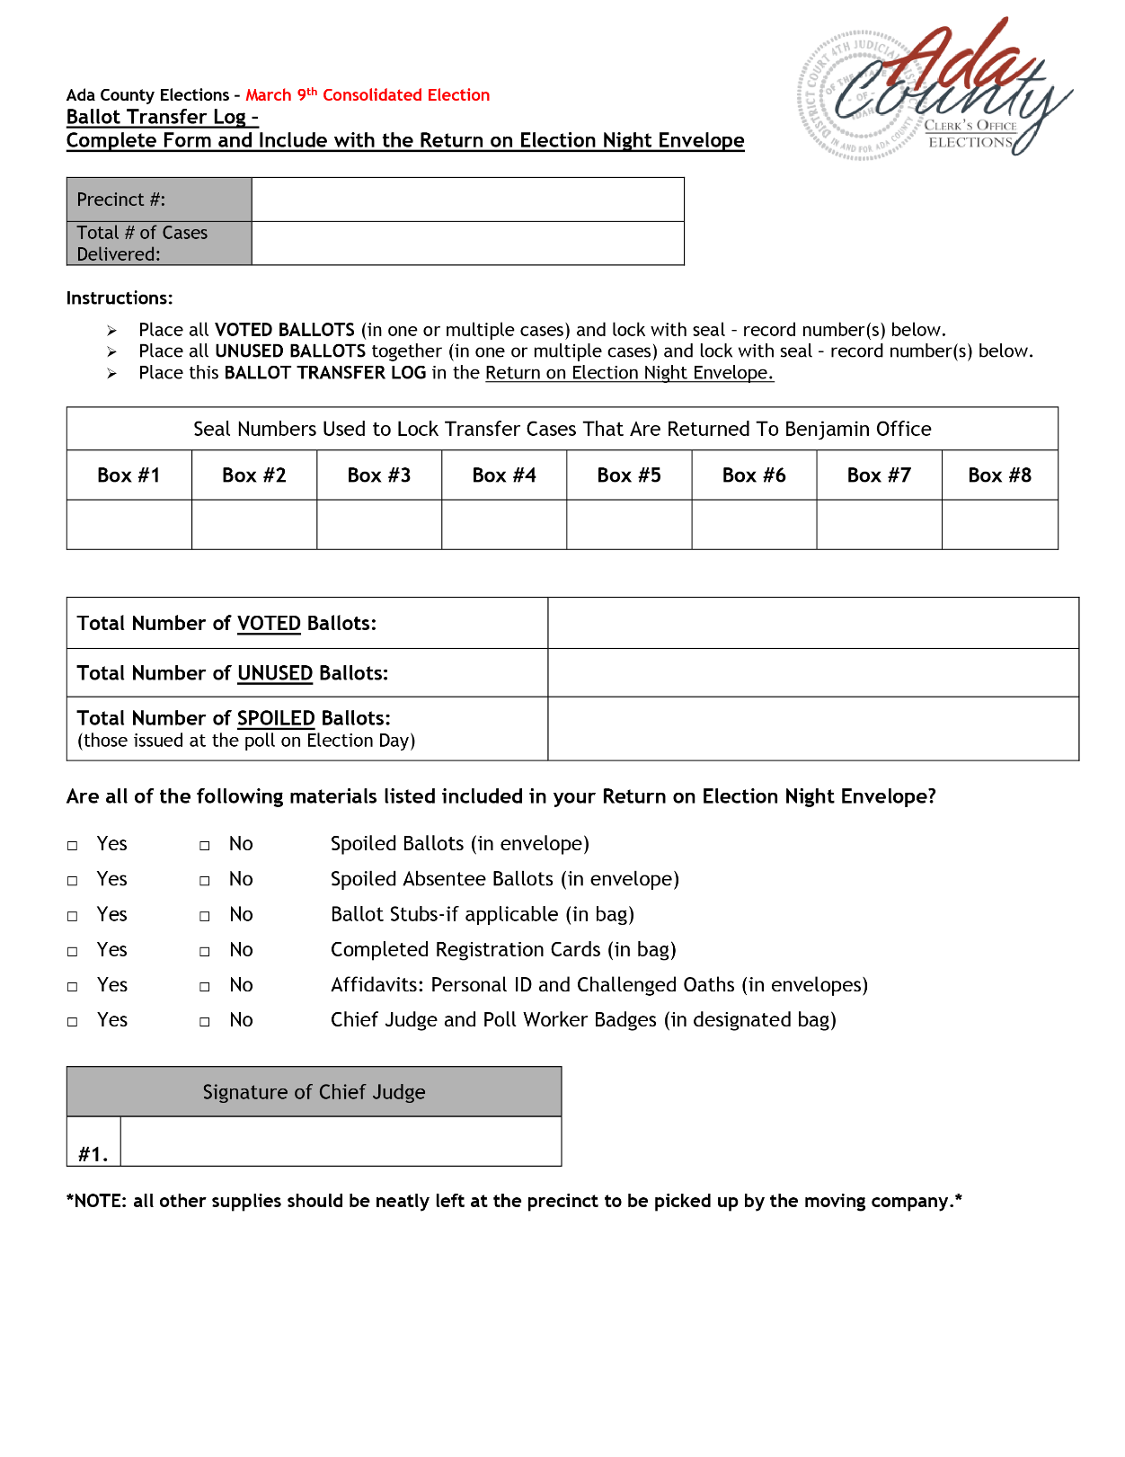
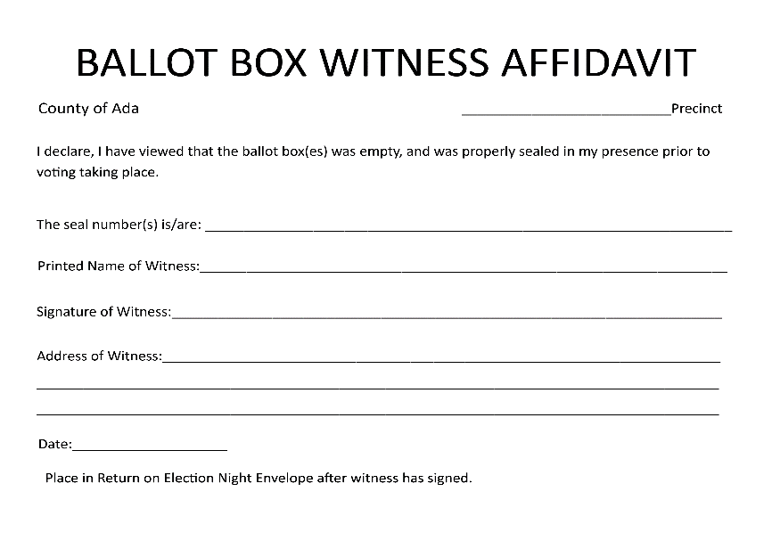
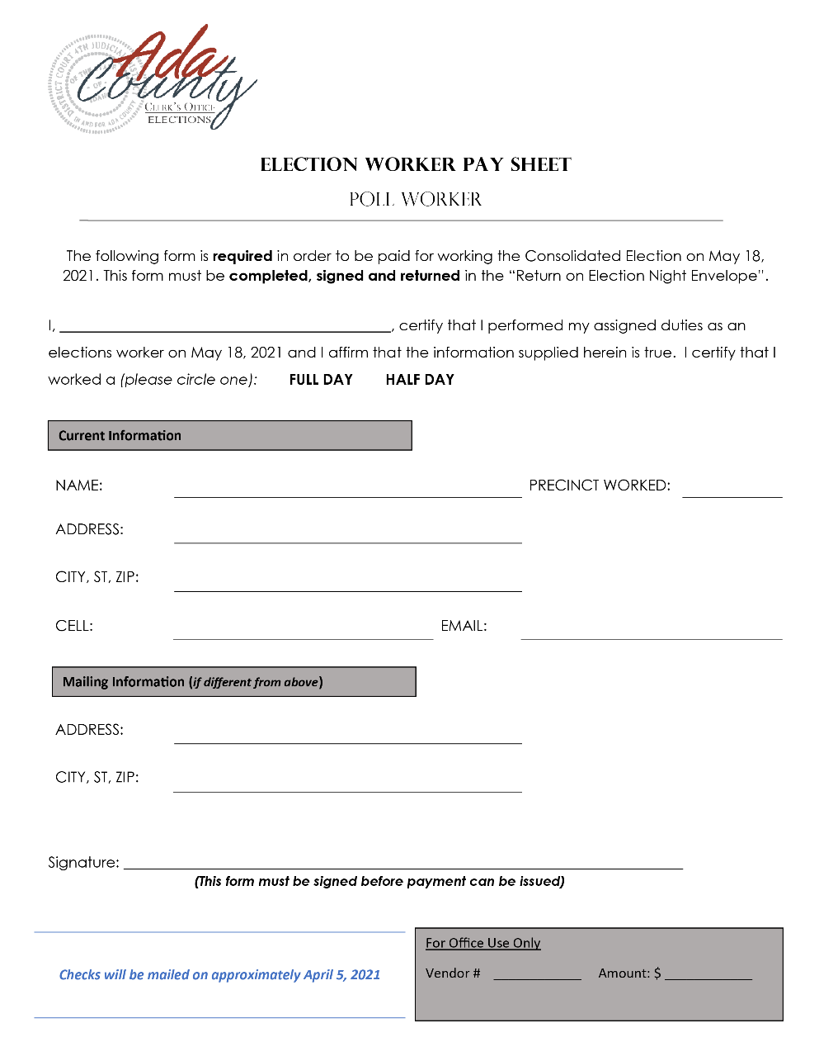

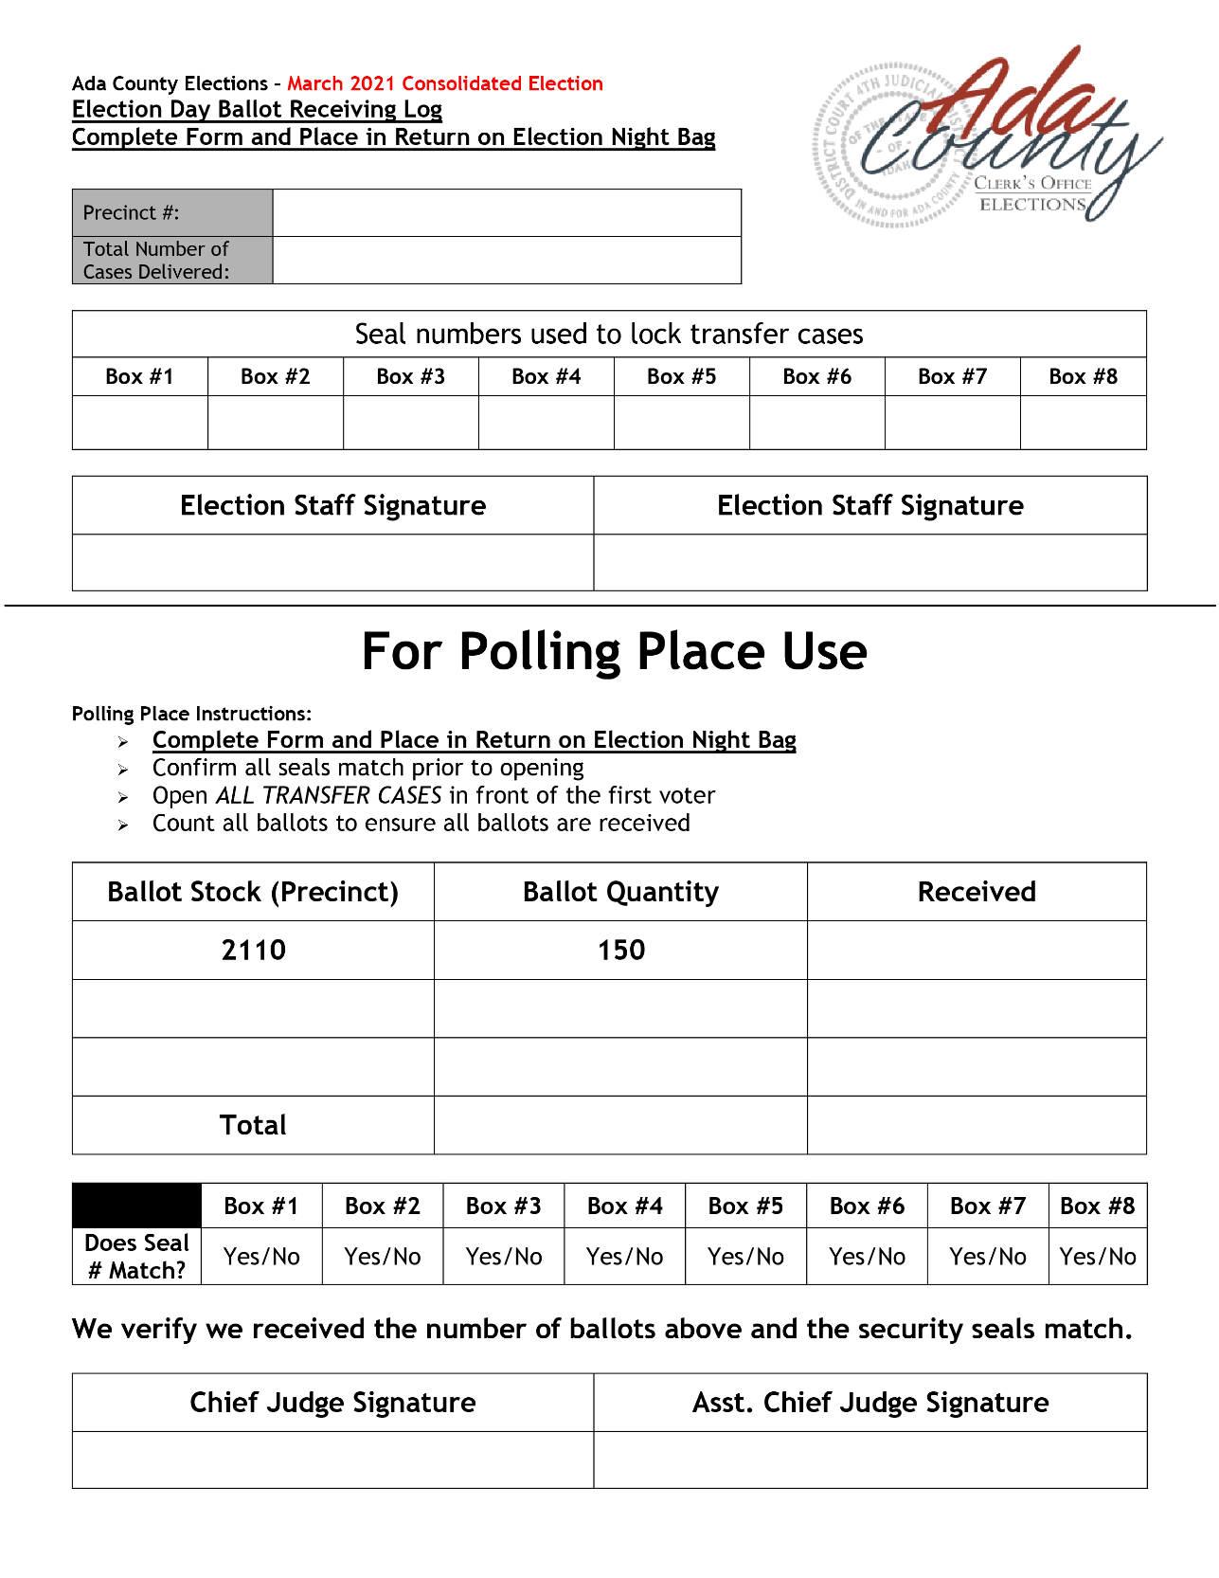

APPENDIX D
Sample Frequently Asked Questions for Poll Workers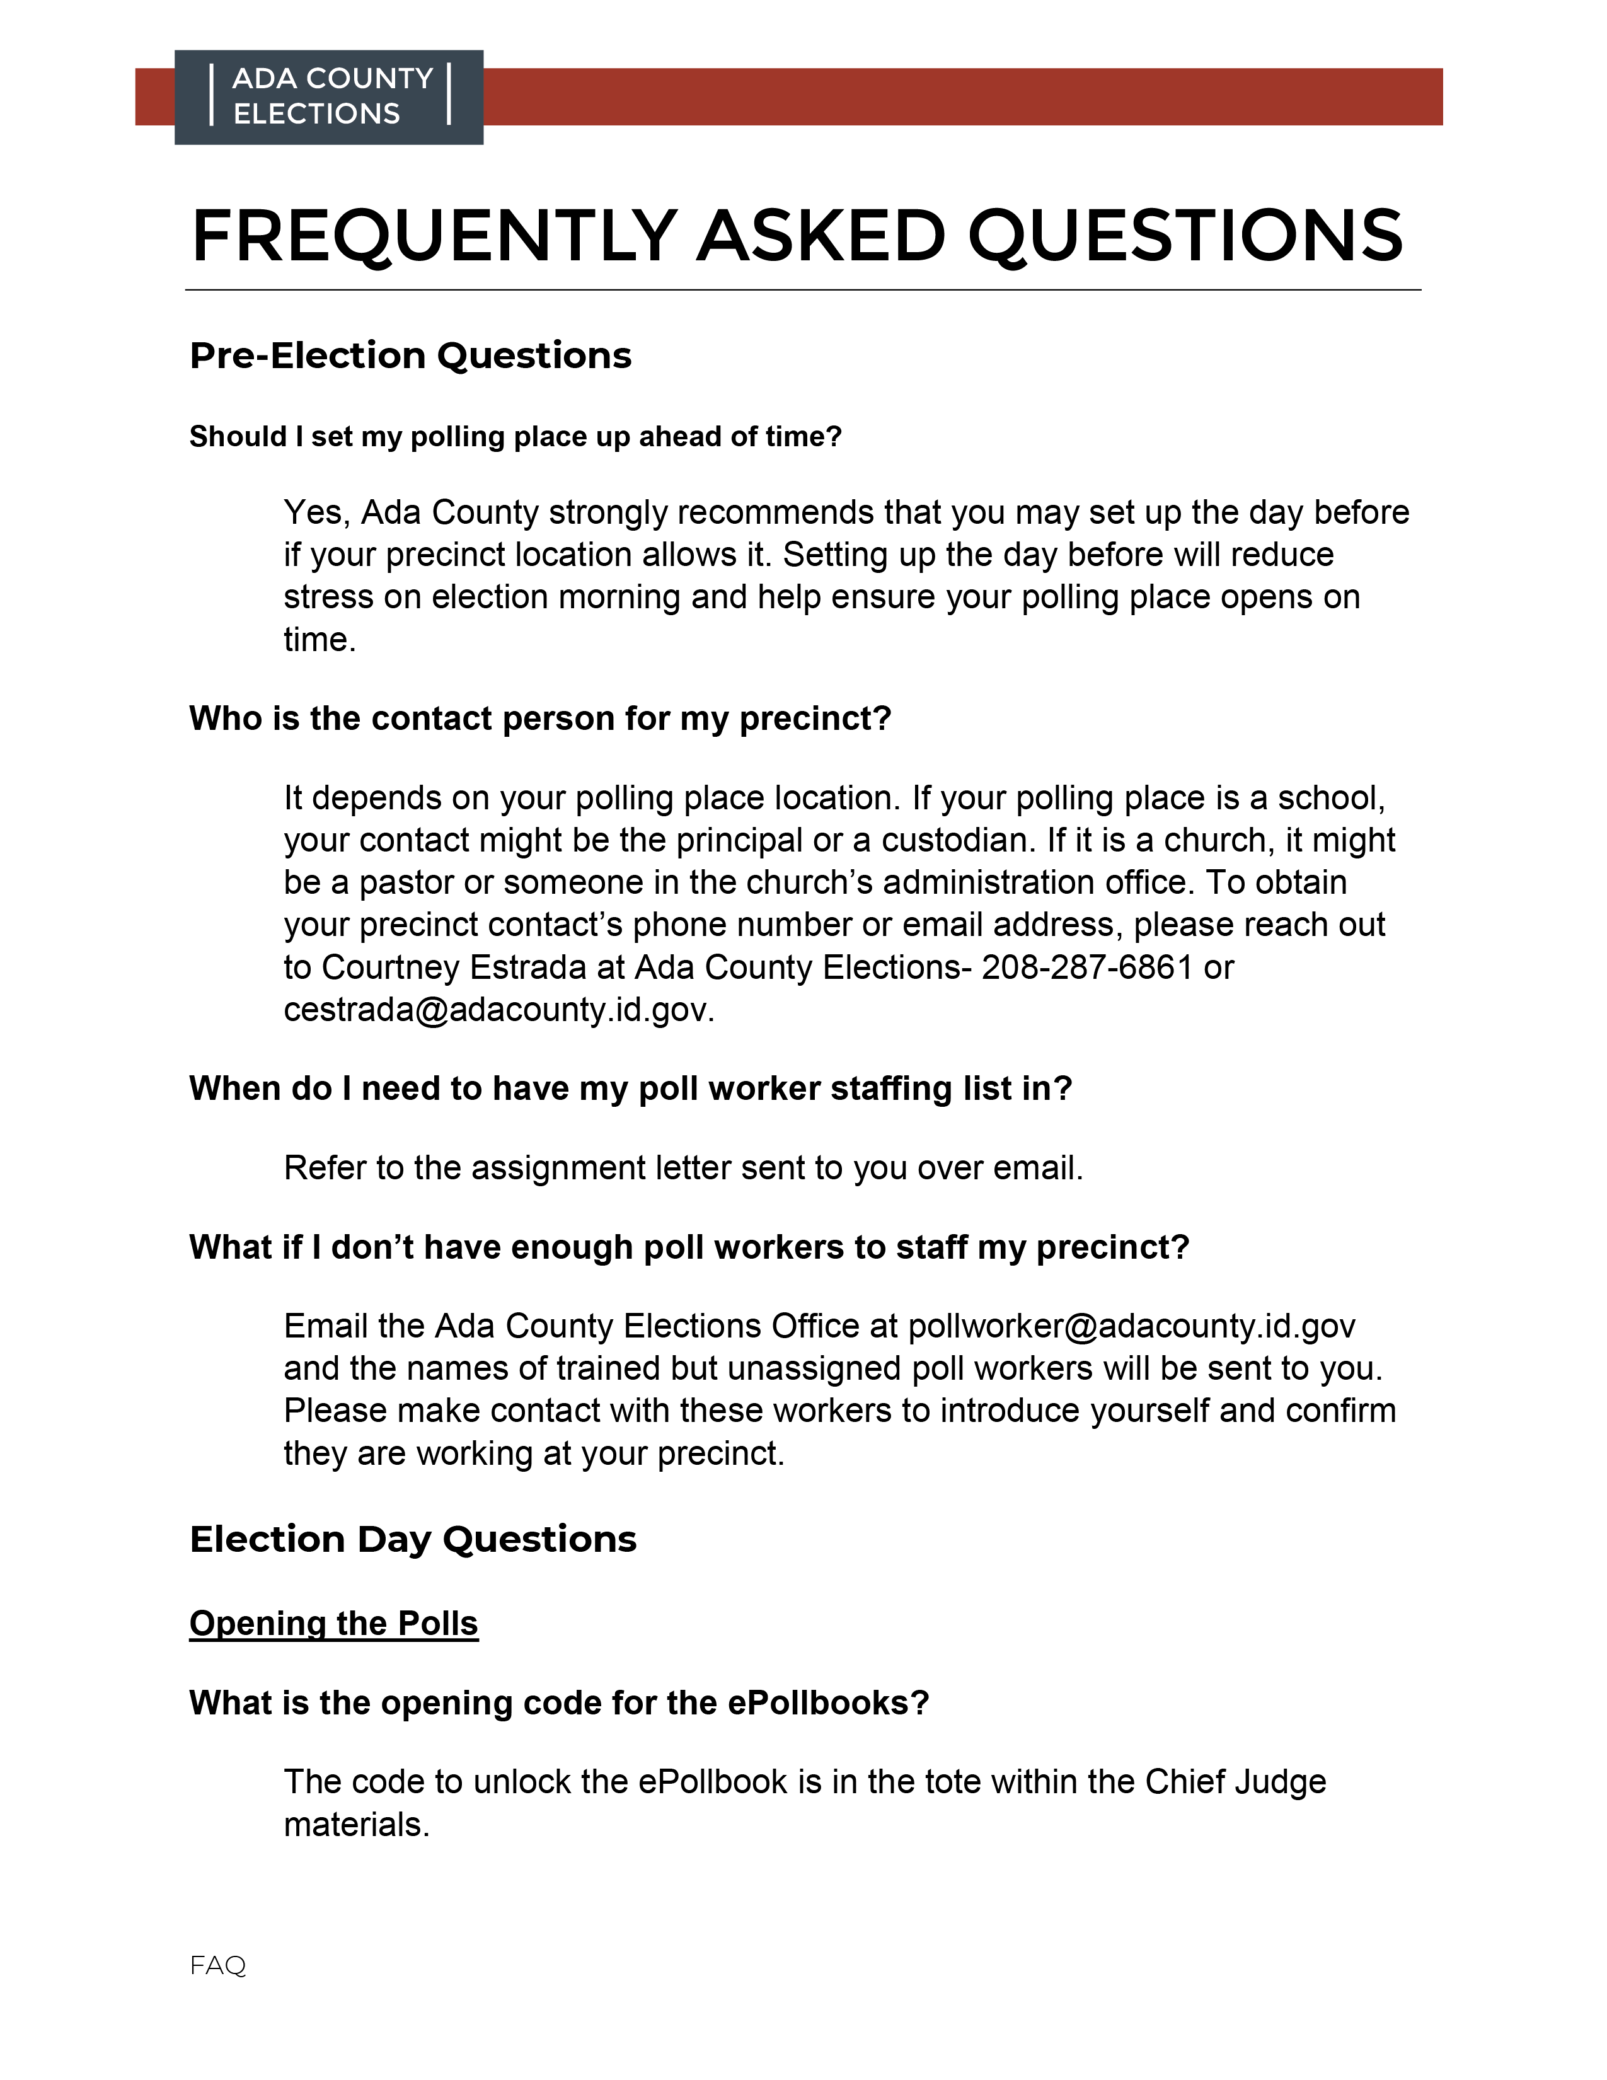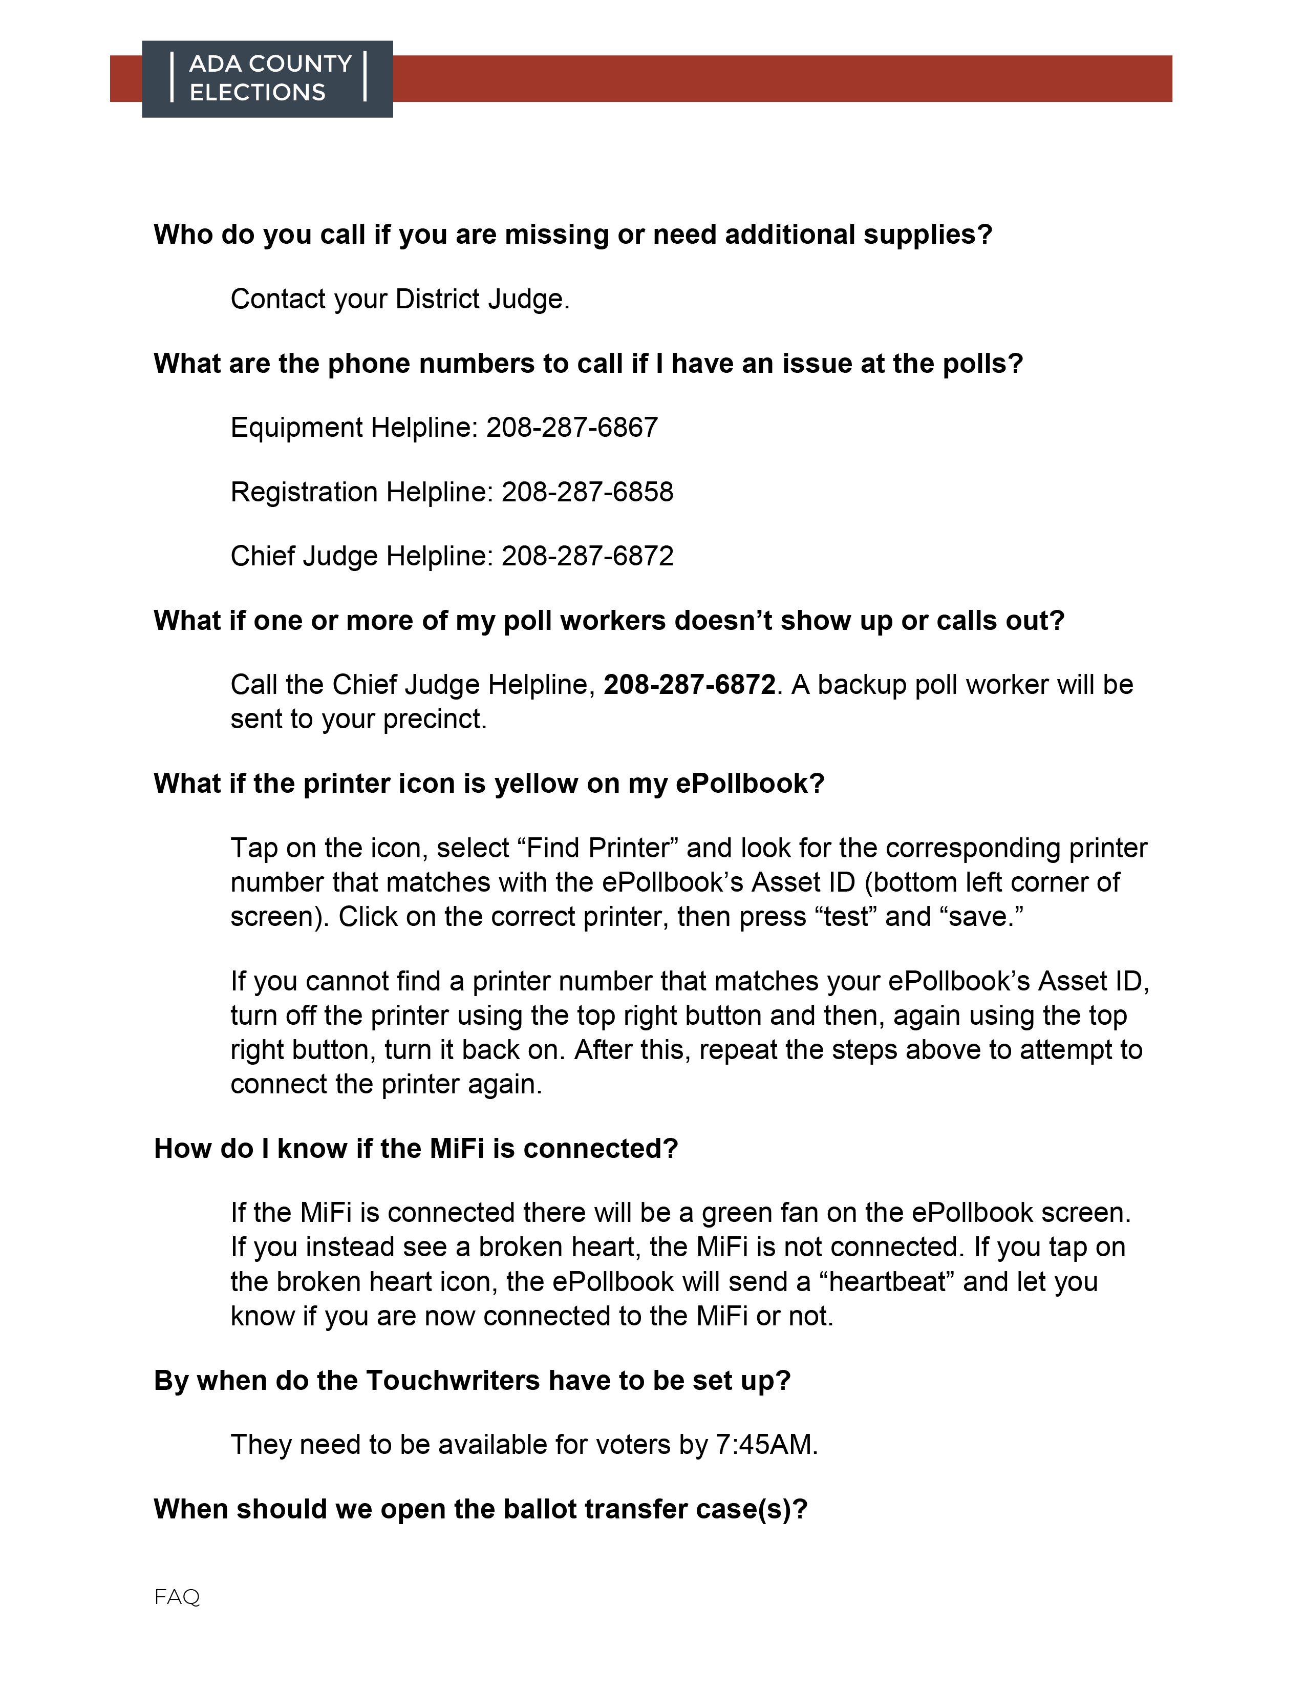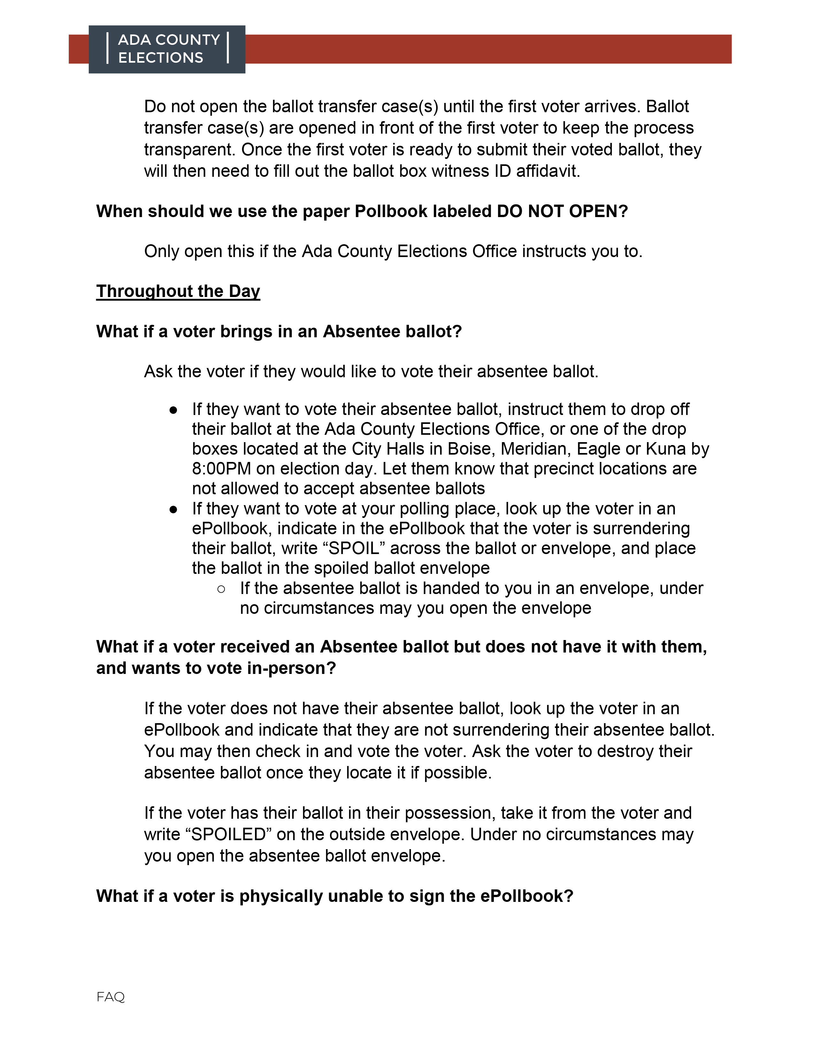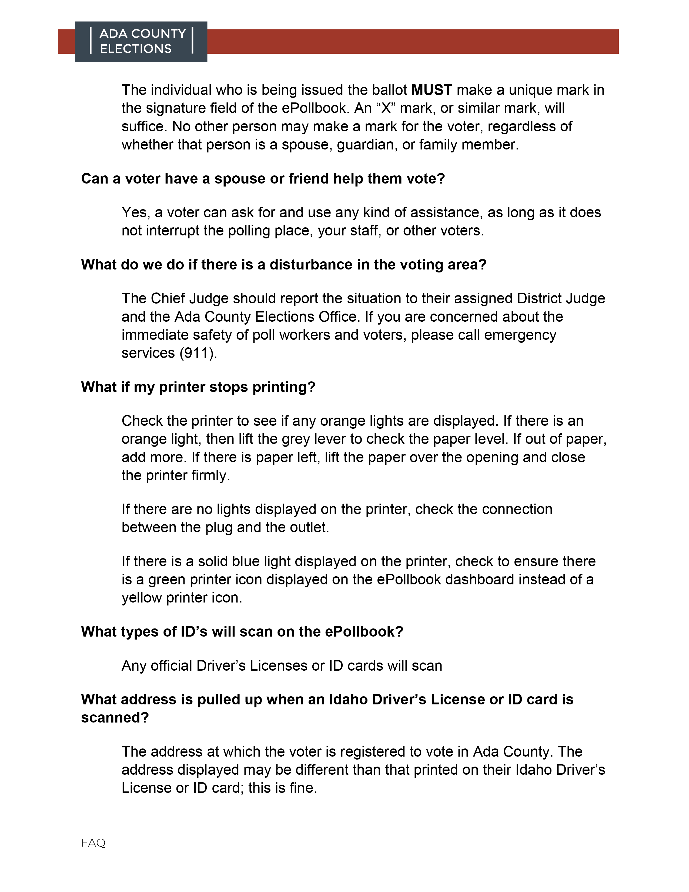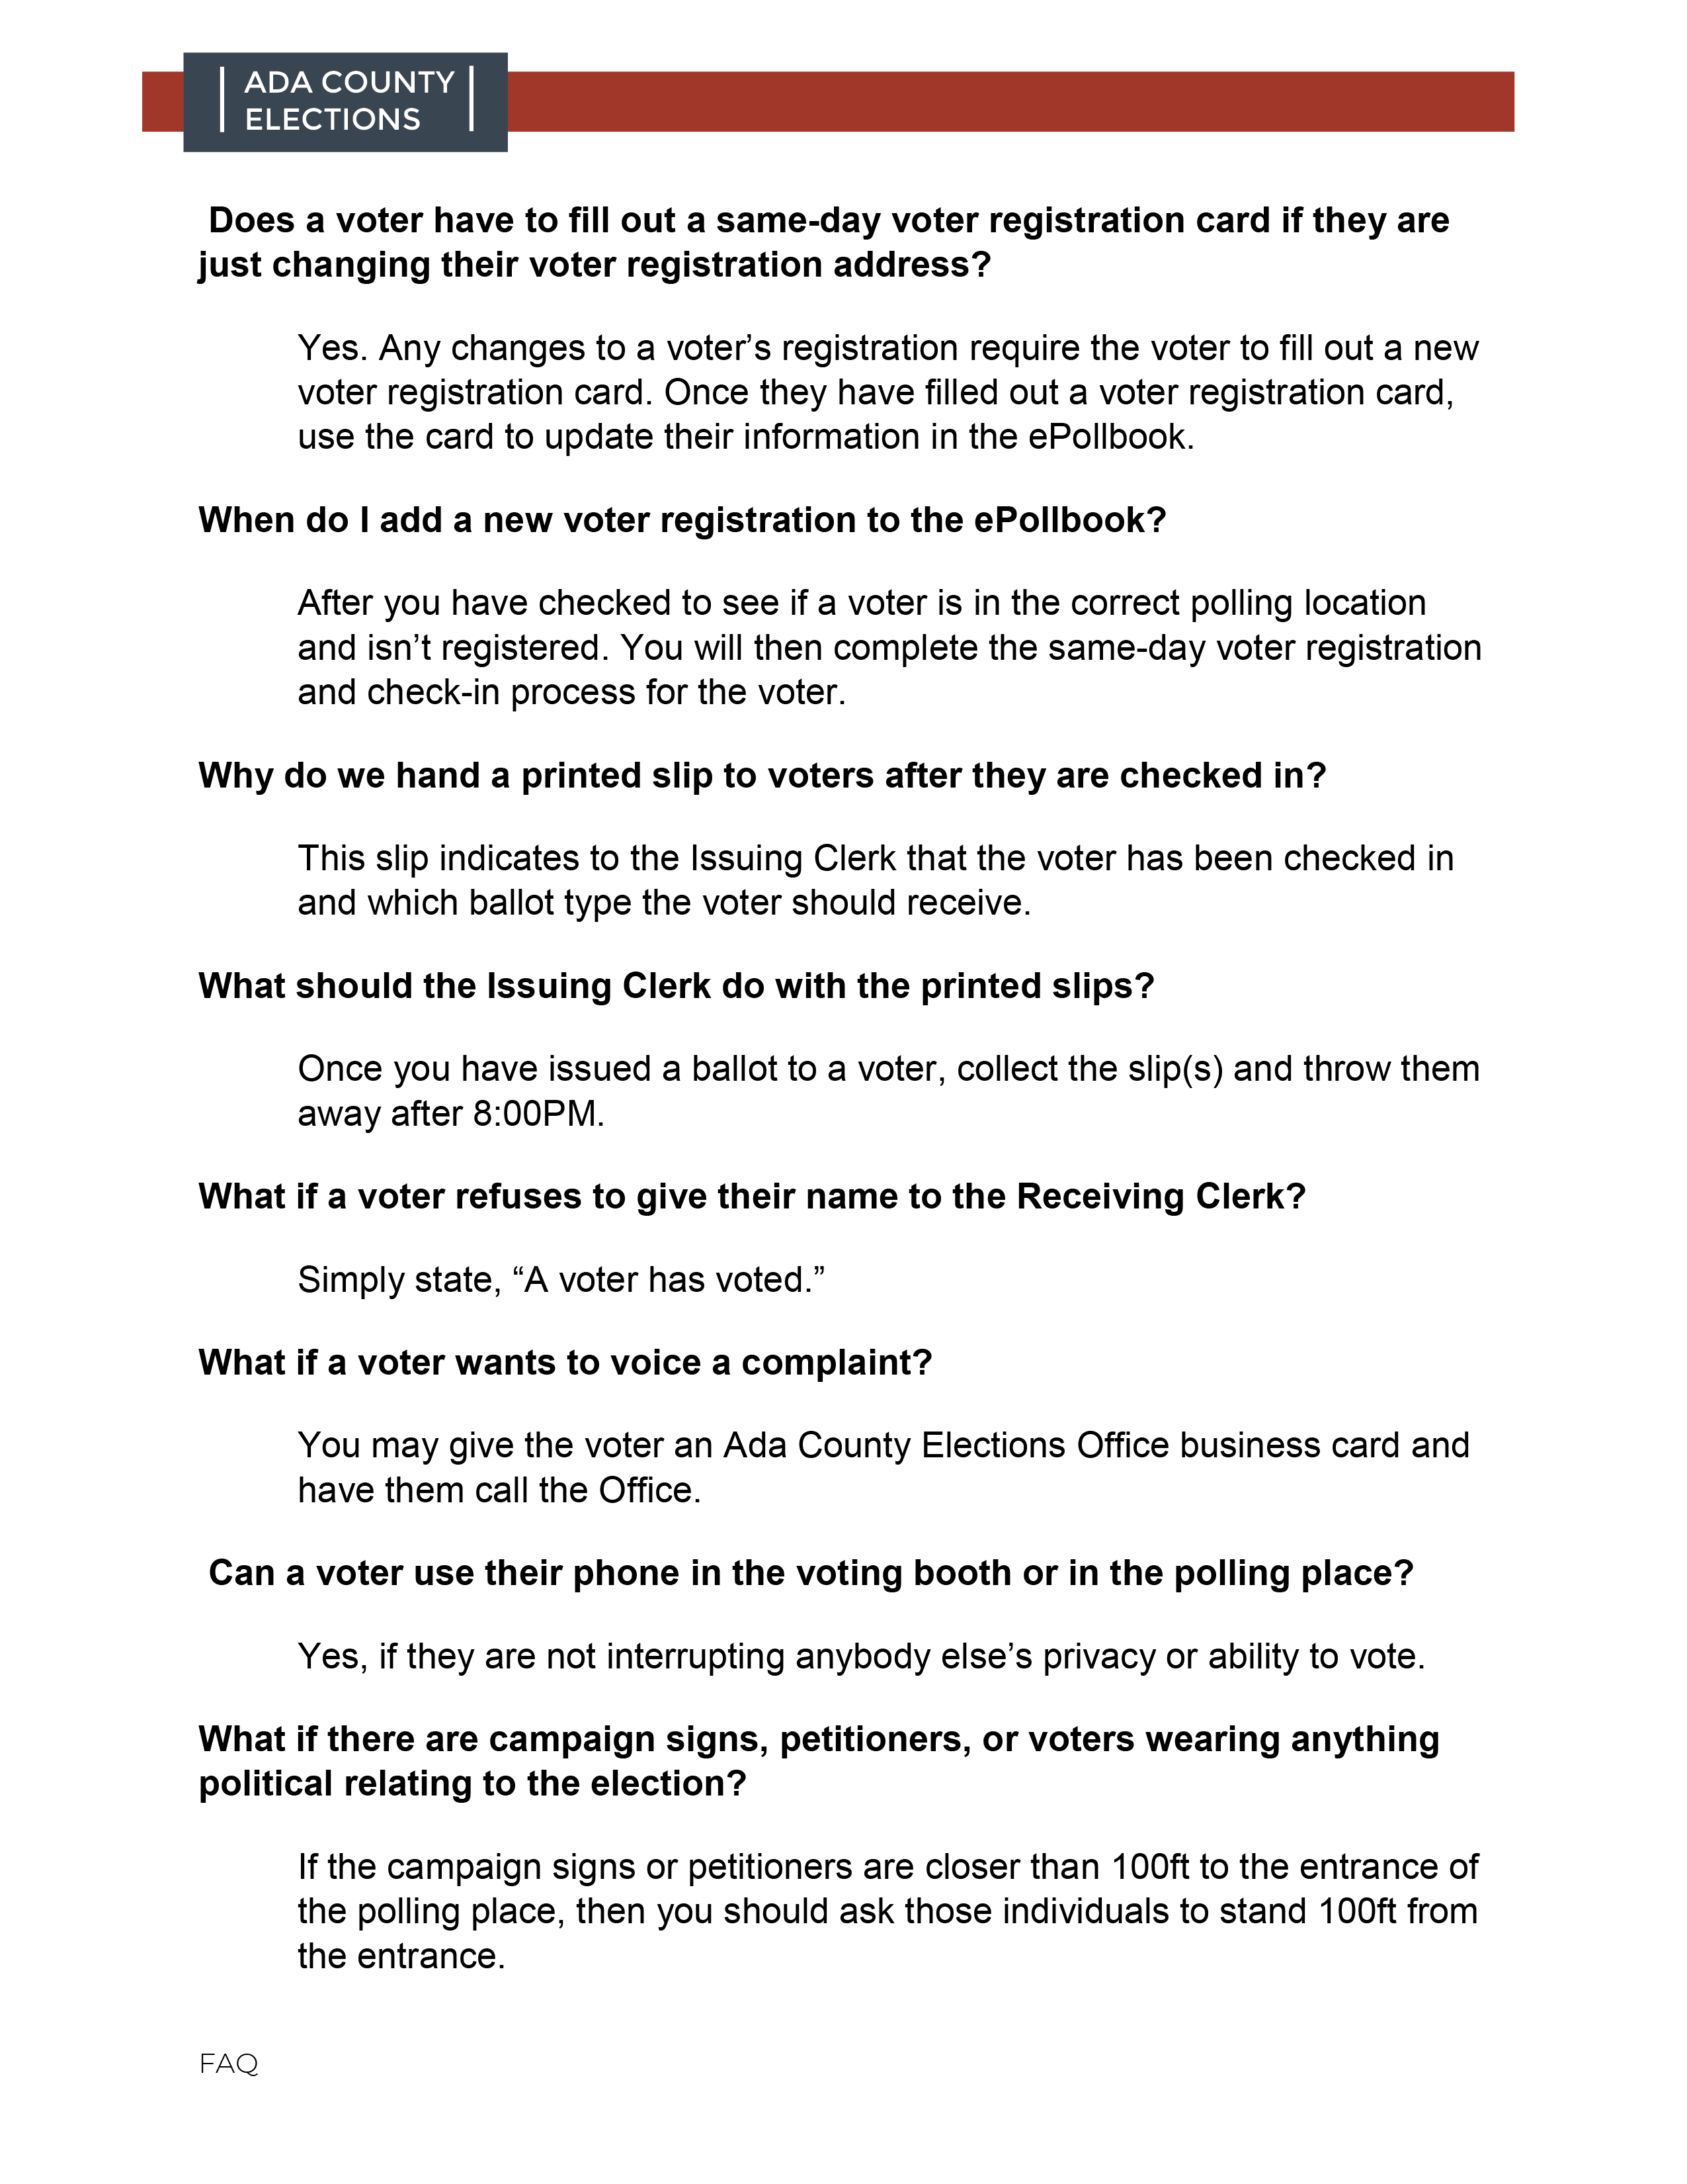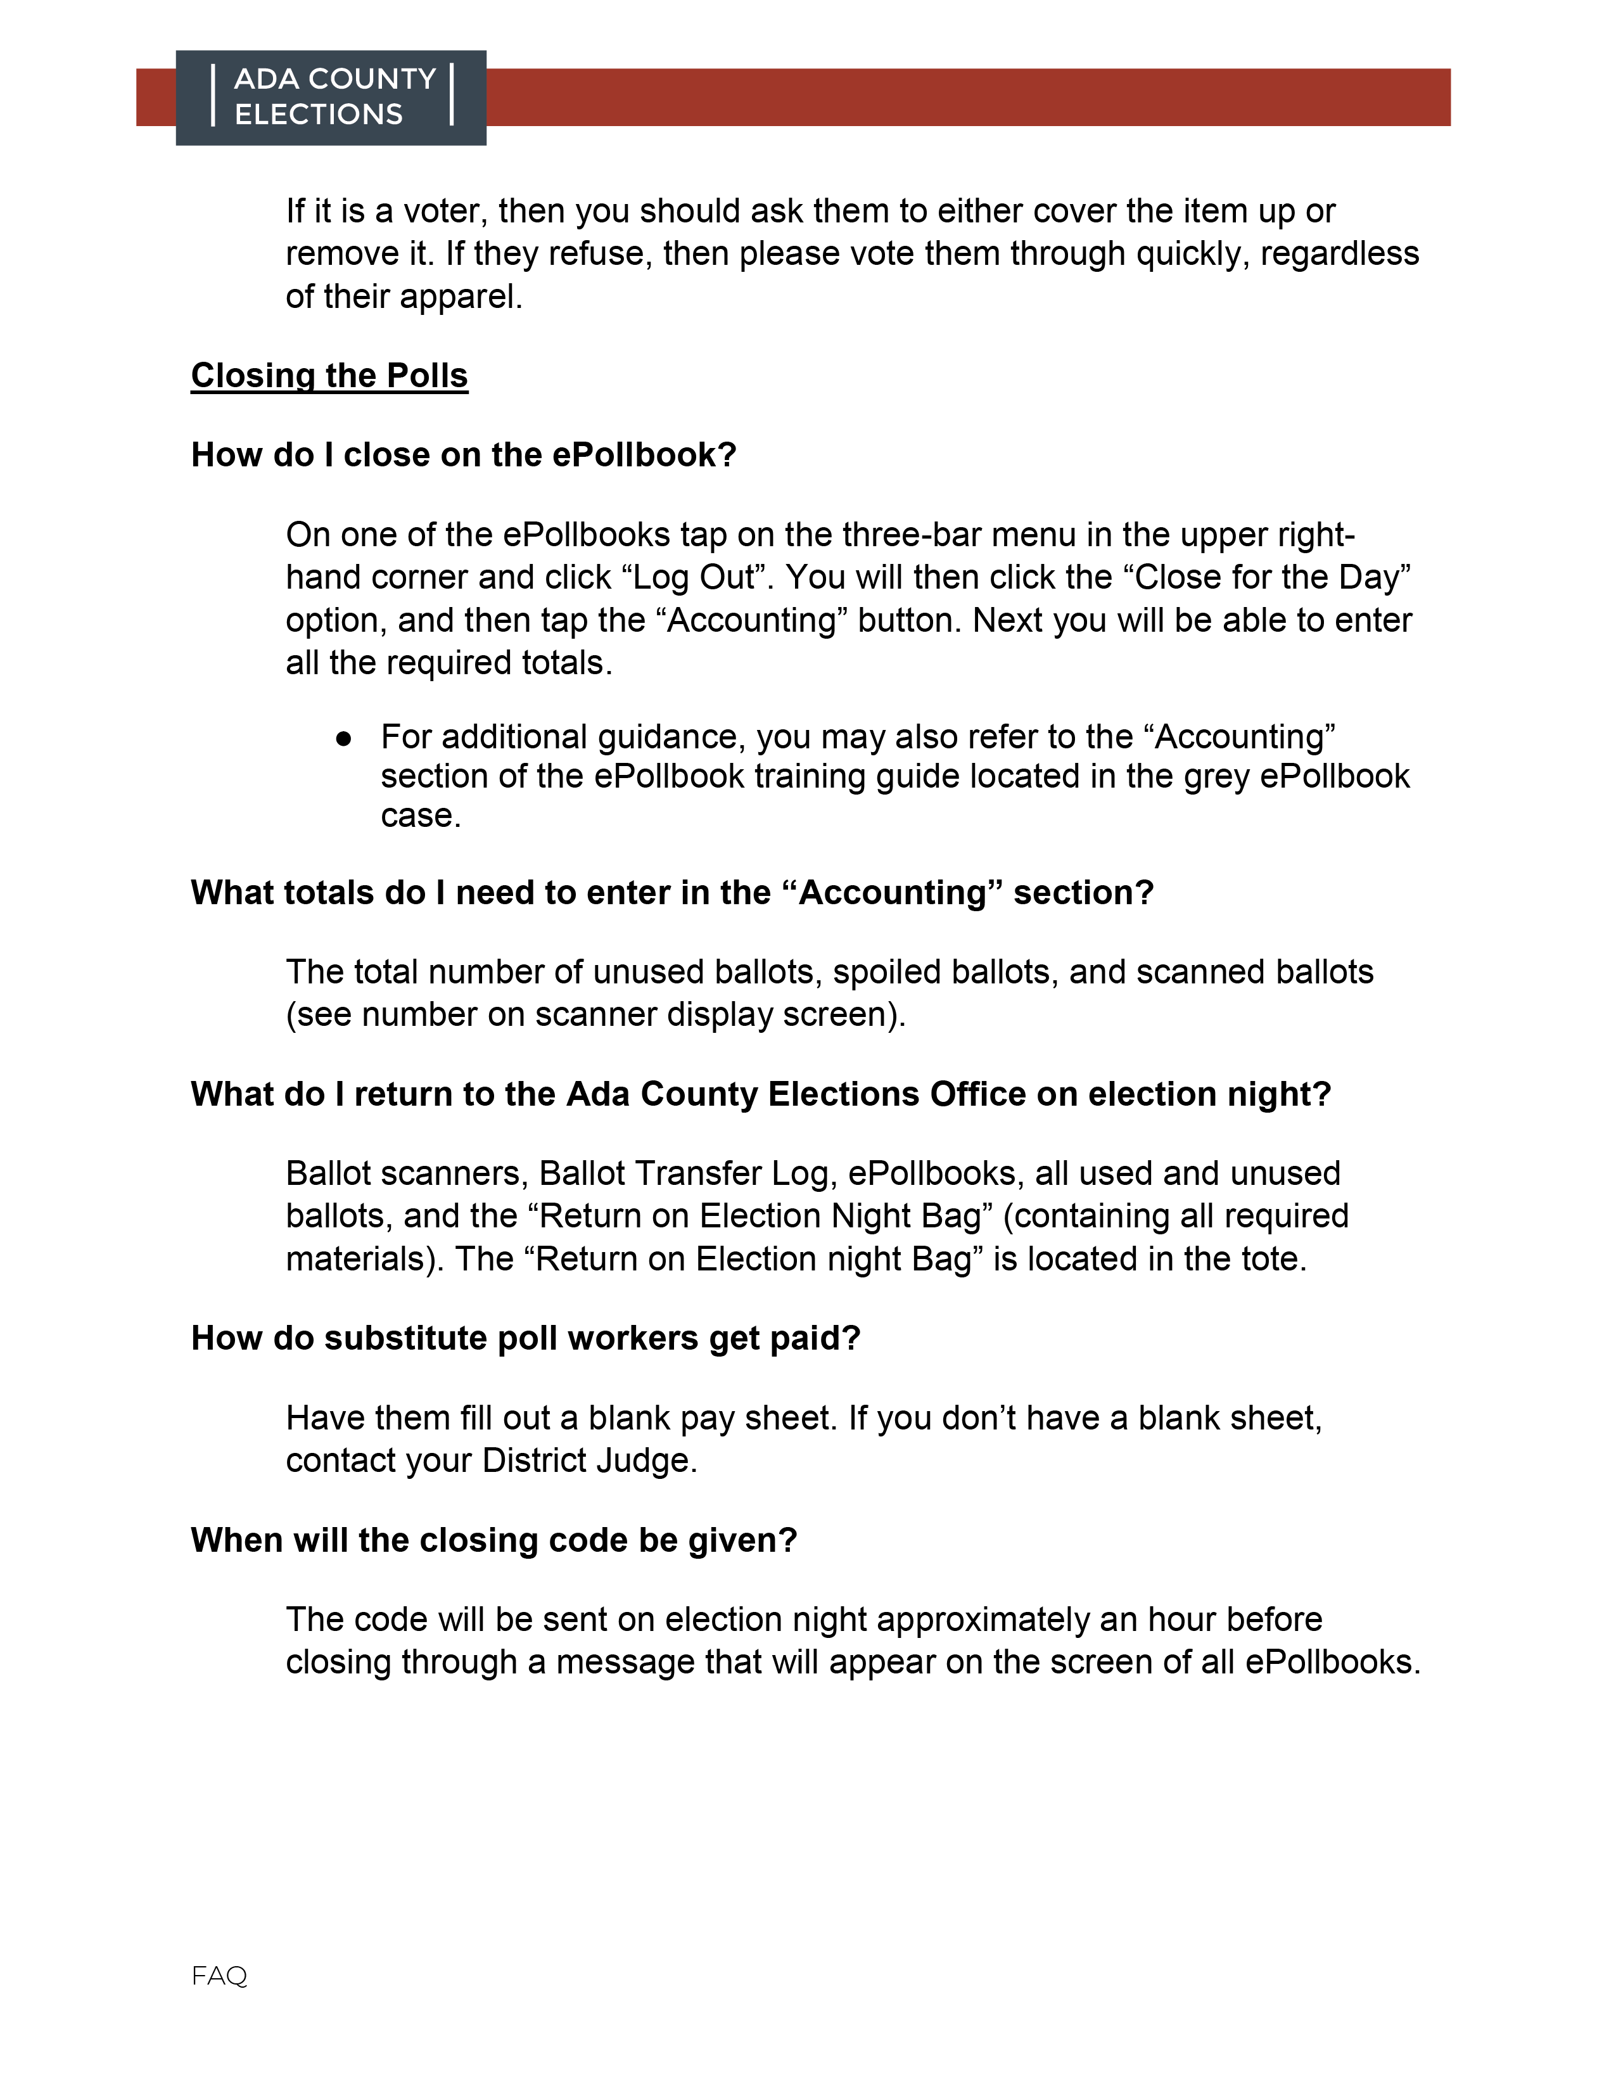

APPENDIX E
Idaho State Code

Titles 18 and 34 of the Idaho Elections Code governs elections in the state. An up-to-date version of these Titles may be viewed online at: https://legislature.idaho.gov/statutesrules/idstat/title34/

